# **Hardware Setup Instructions:**

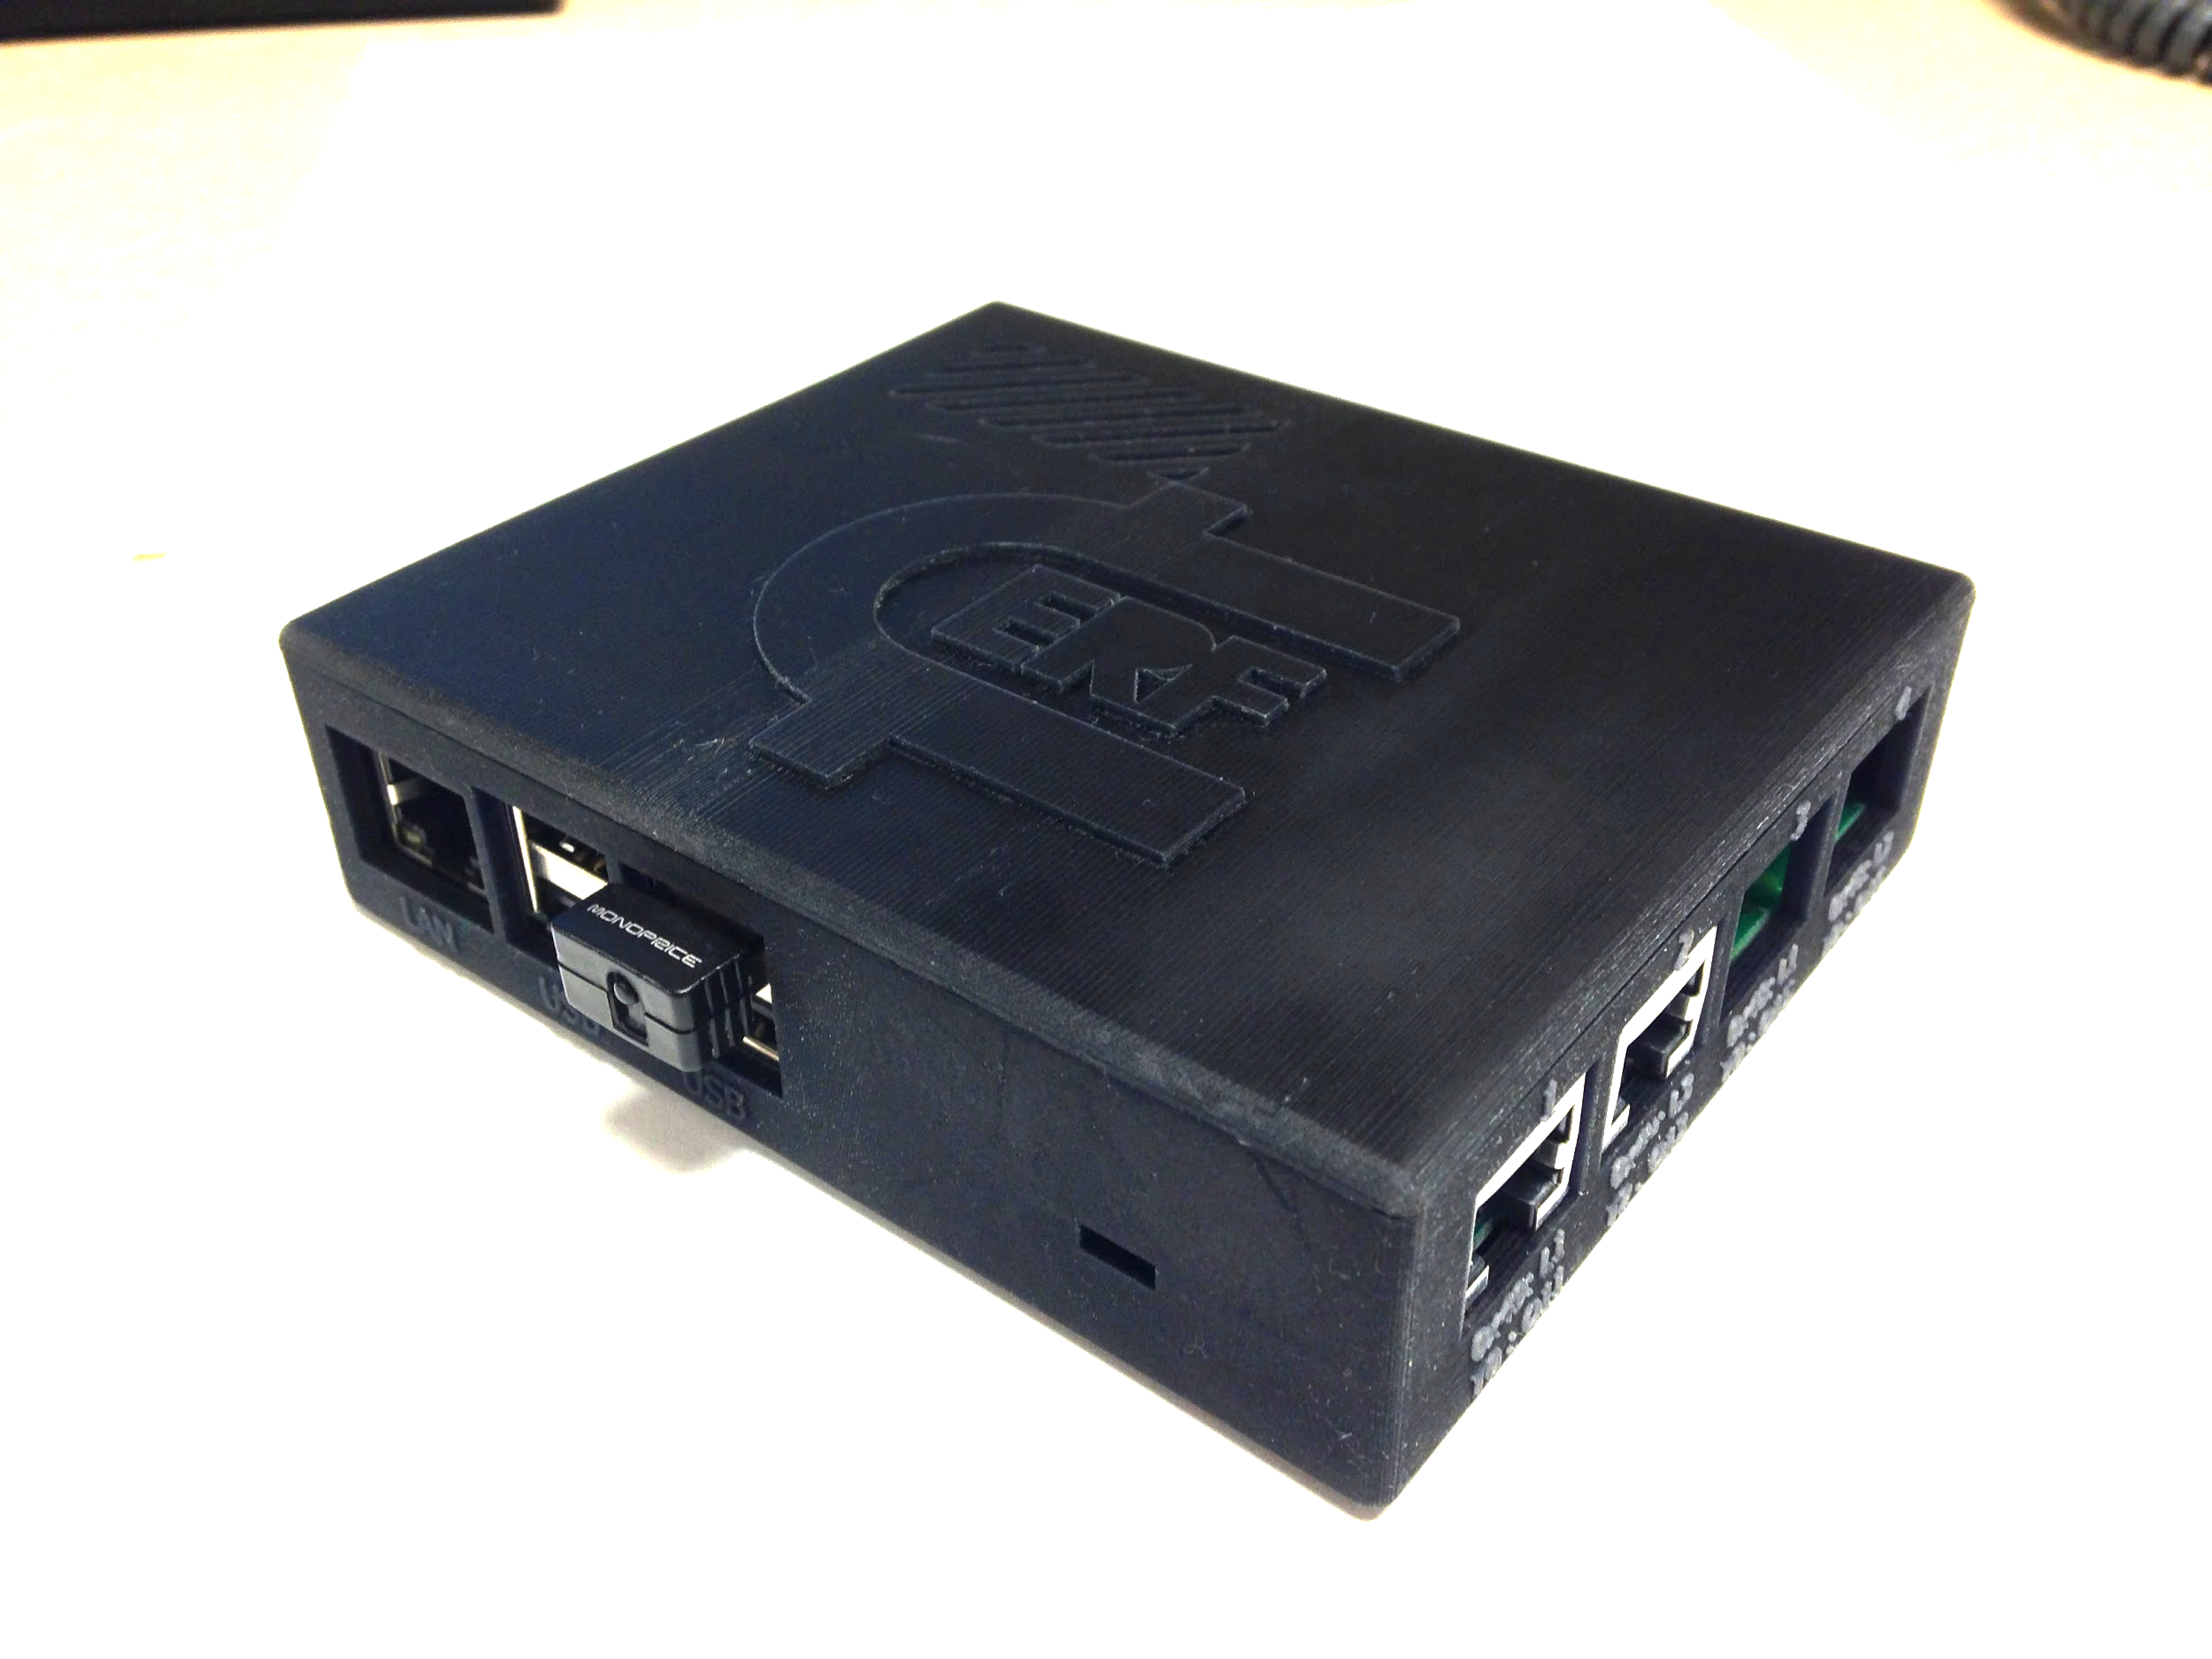

**Hardware Setup Instructions:**

**Soldering the Hub Circuit Board:**

Soldering the RJ-45 Jacks:

Soldering the ADC:

**Soldering the Sensors:**

Soldering the RJ-45 Jack:

Soldering the 3.5mm Jack:

Soldering the PIR:

Soldering the Resistor:

Soldering the Light Sensor:

**Connecting The Raspberry Pi to the Hub:**

## Soldering the Hub Circuit Board:

Start by taking out the hub circuit board, or the board that will go in the box with the Raspberry Pi as pictured below:



### Soldering the RJ-45 Jacks:

We will start by soldering the RJ-45 jacks onto the circuit board. To begin push the jacks into the corresponding spaces labeled on the circuit board. Work on the side of the circuit board that has the white printing on it.

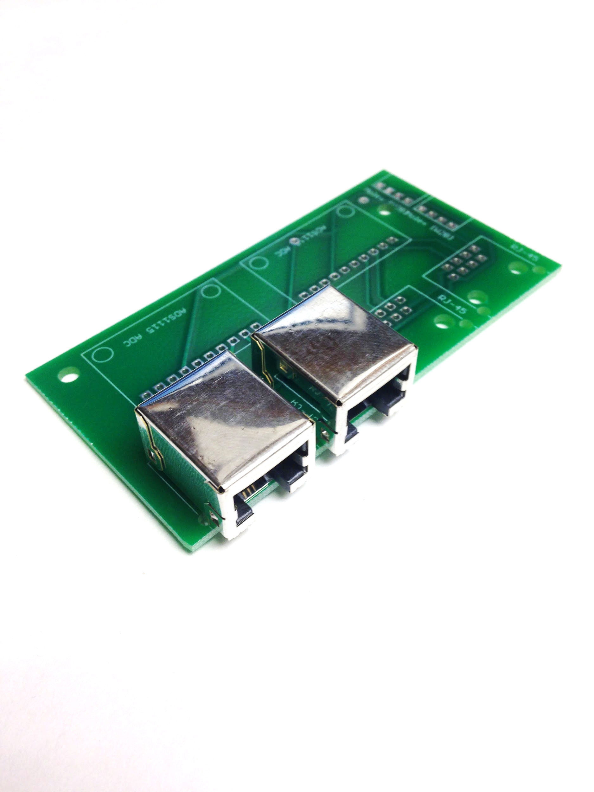

After the jacks are in the board. Fold over the tabs and ensure the jacks are flush to the surface of the printed circuit board.

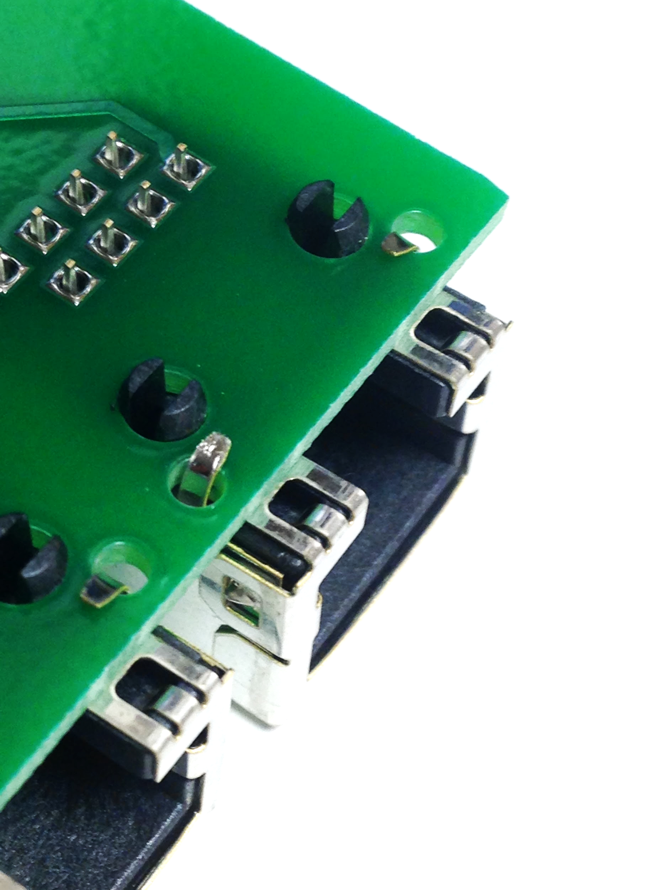

Finally, solder the RJ-45 jacks to the board while again ensuring the board is flush to the jack.

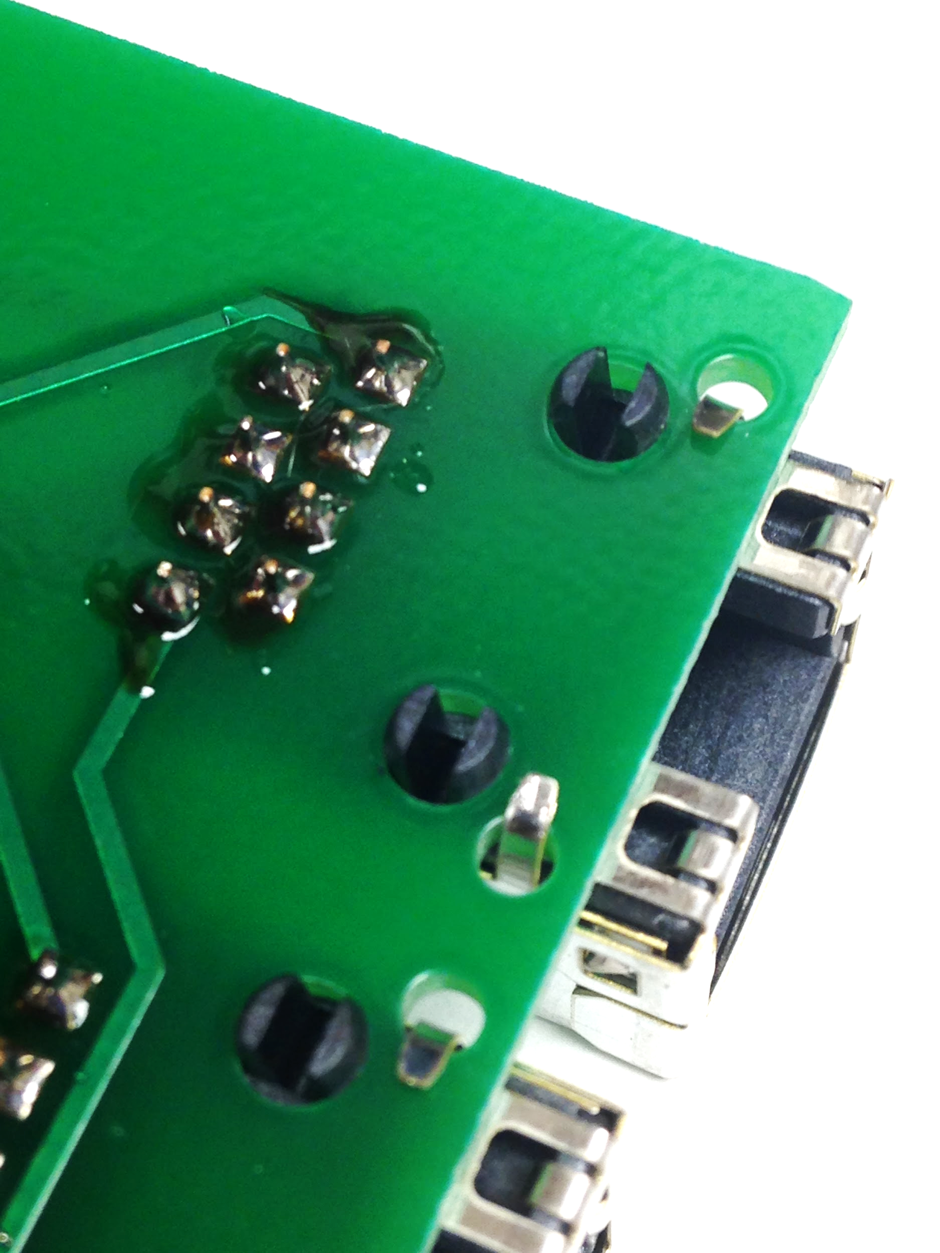

### Soldering the ADC:

Start by breaking the correct number of pins needed for the ADC (10).

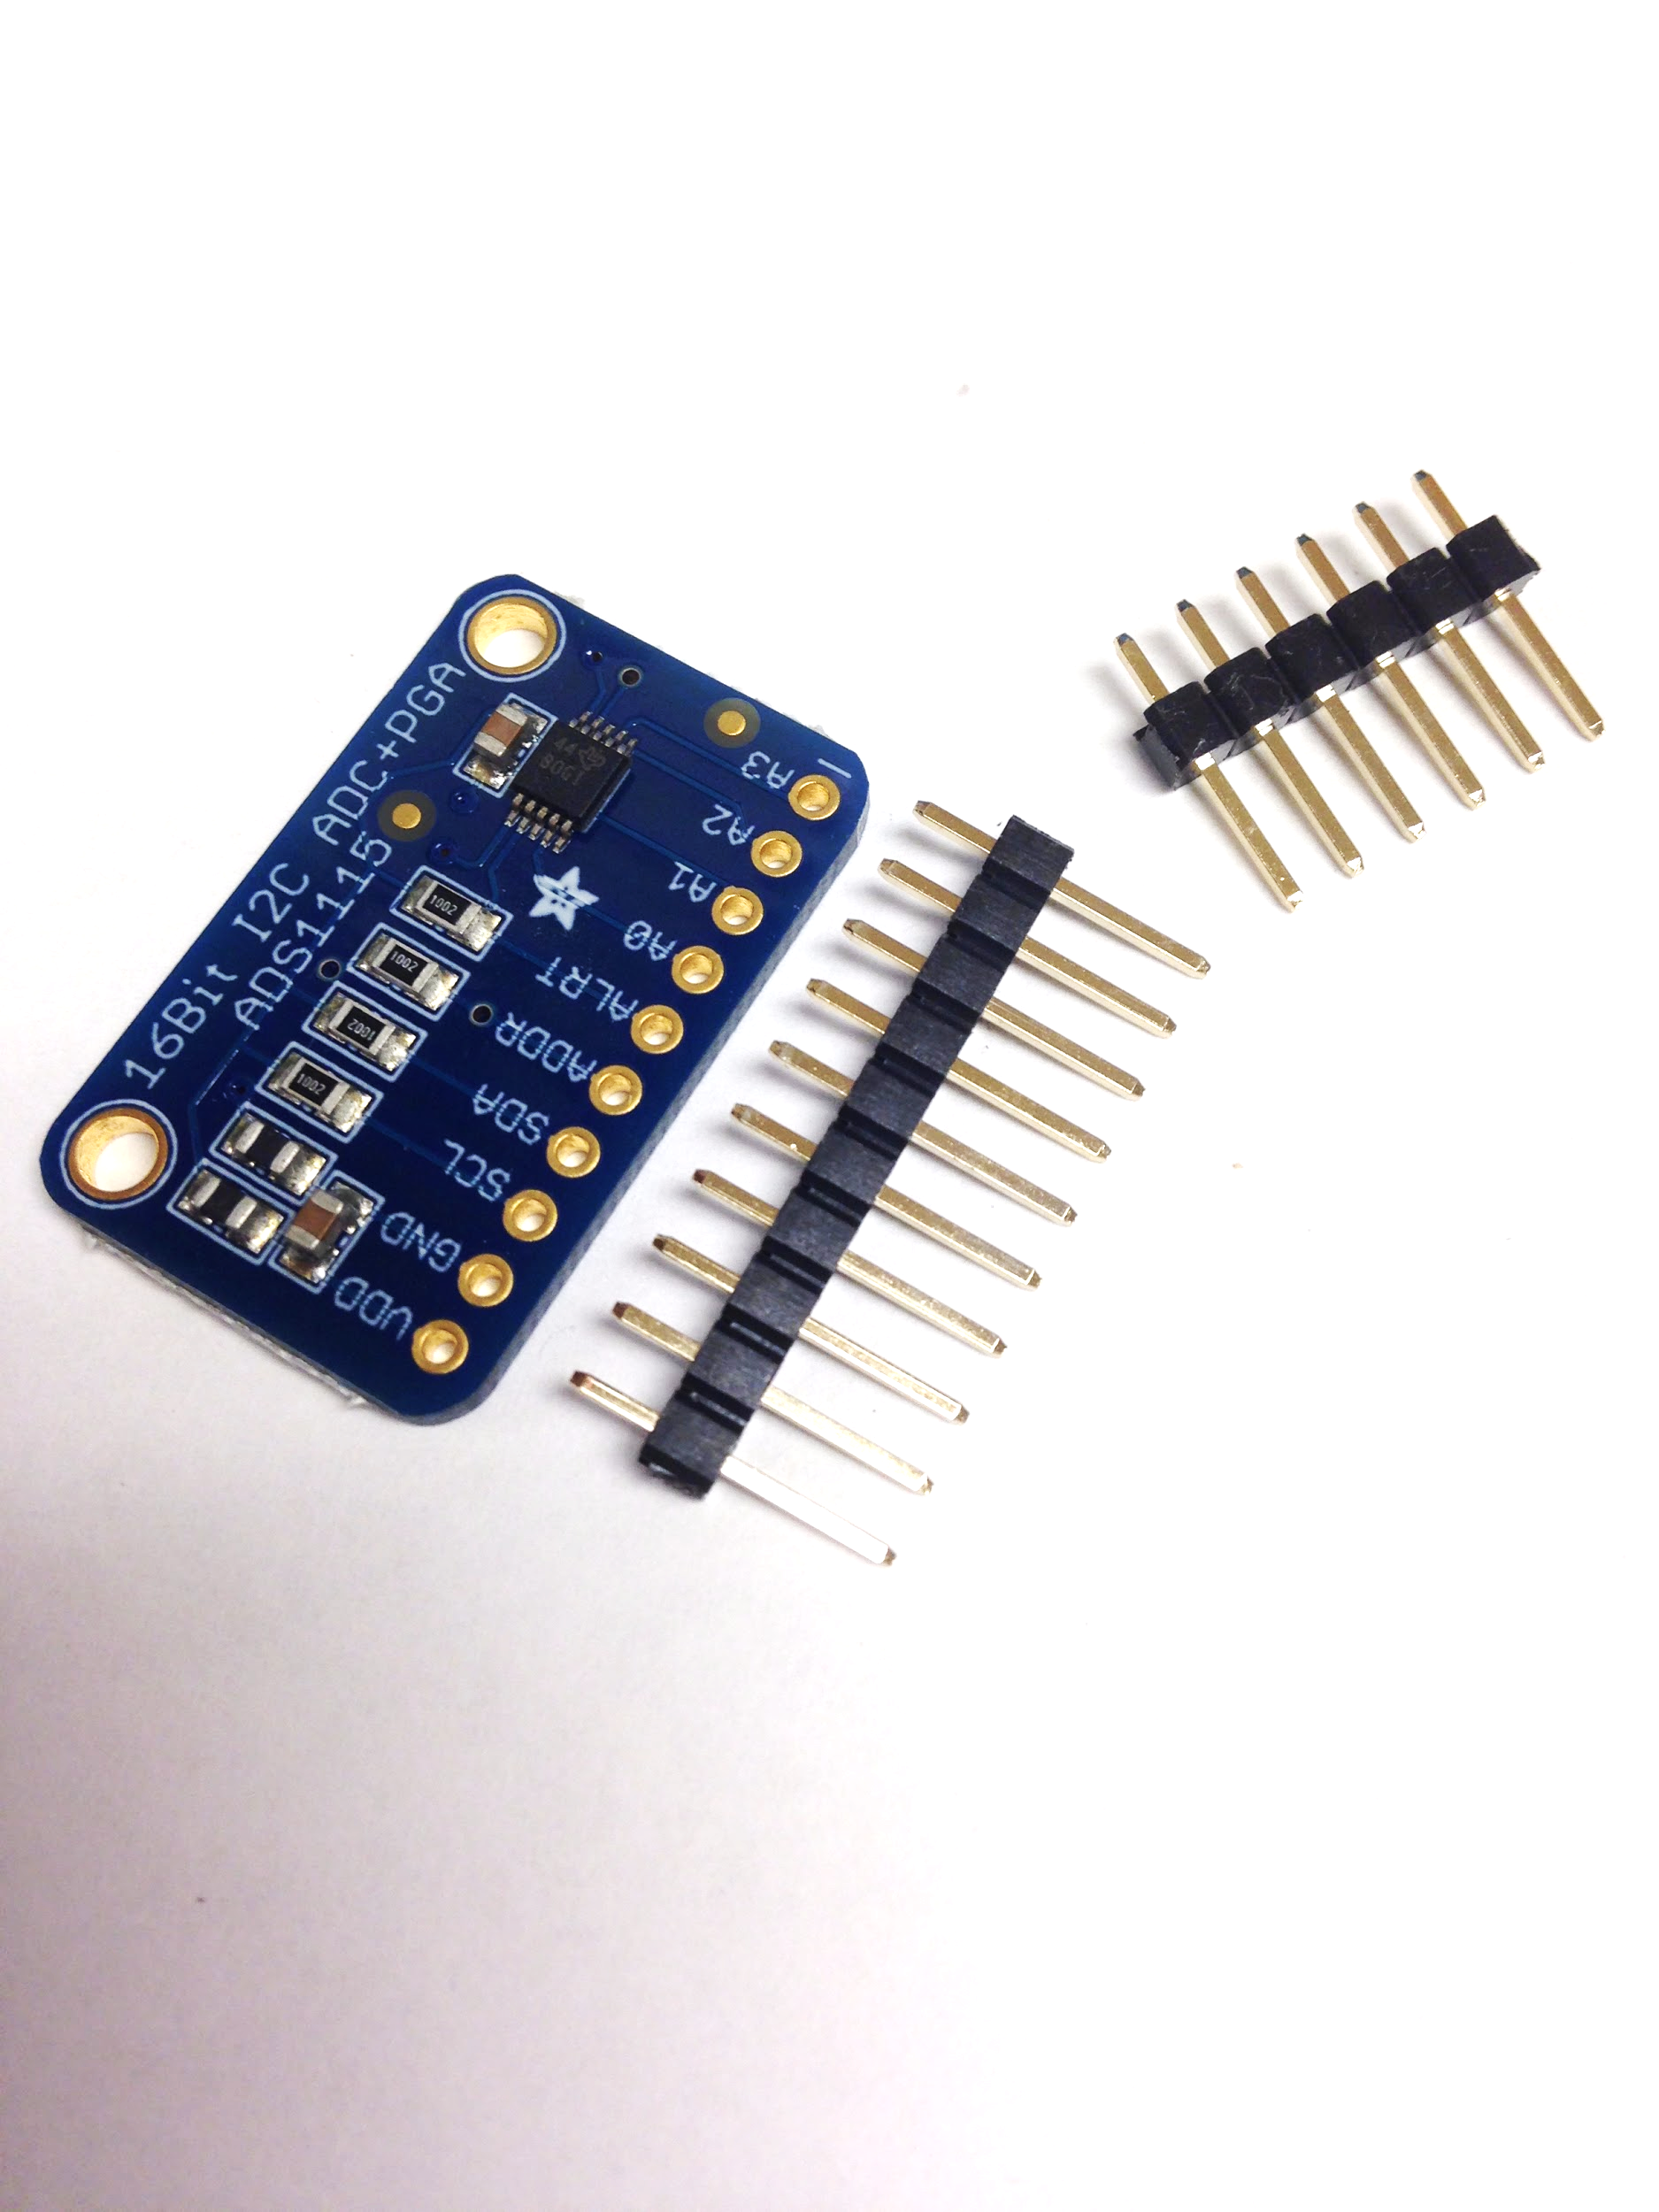

Now solder the pins to the ADC so that the short end of the pins comes out the top of the ADC. Ensure the pins are perpendicular to the ADC.

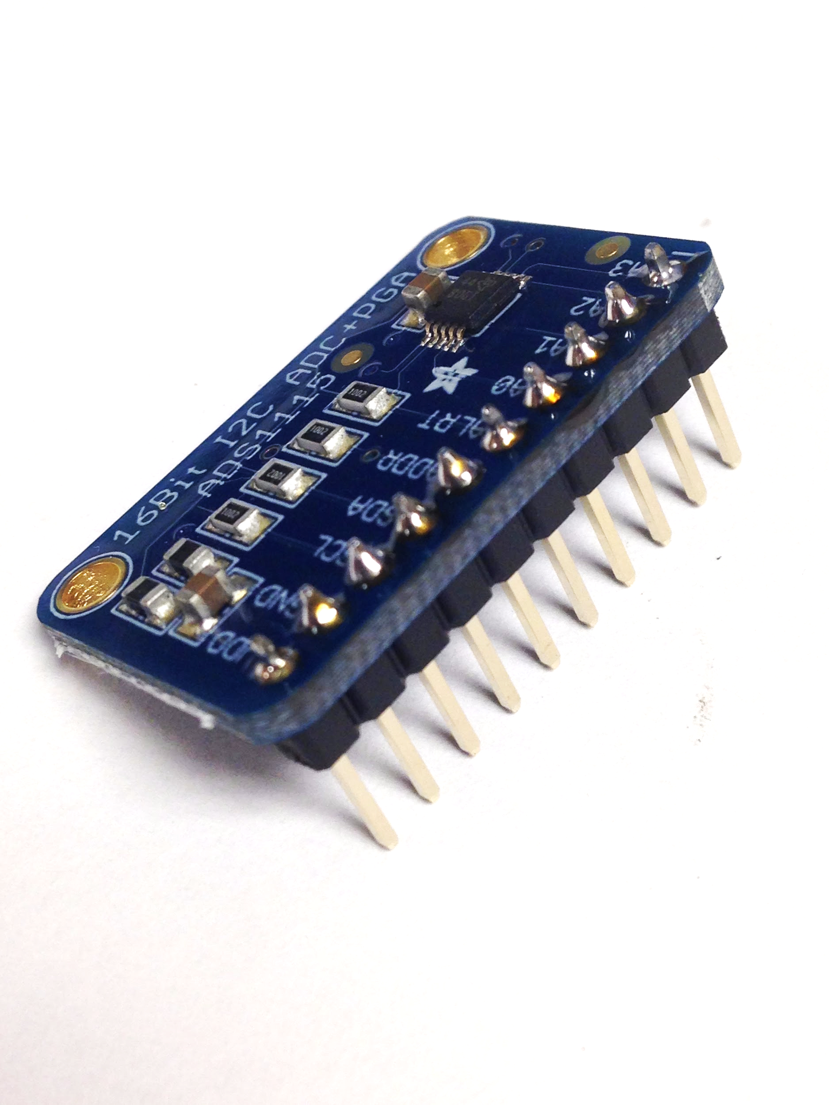

Finally, solder the ADC to the printed circuit board, ensuring that the pins are perpendicular to the printed circuit board. (Note - if only having two inputs, make sure to put the ADC next to the two ethernet inputs as shown)

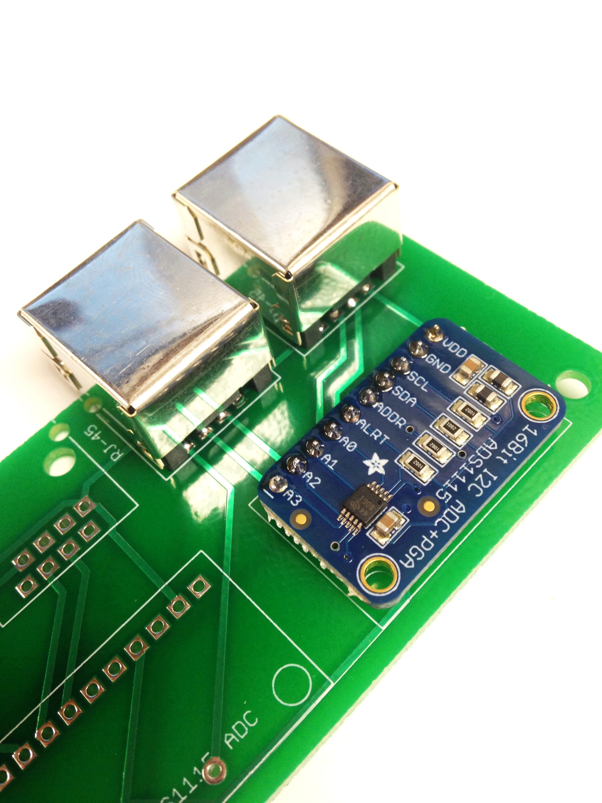

Soldering the Dupont Jumper Cables:  
 Solder eight Dupont jumper cables to the eight solder pads at the end of the board.

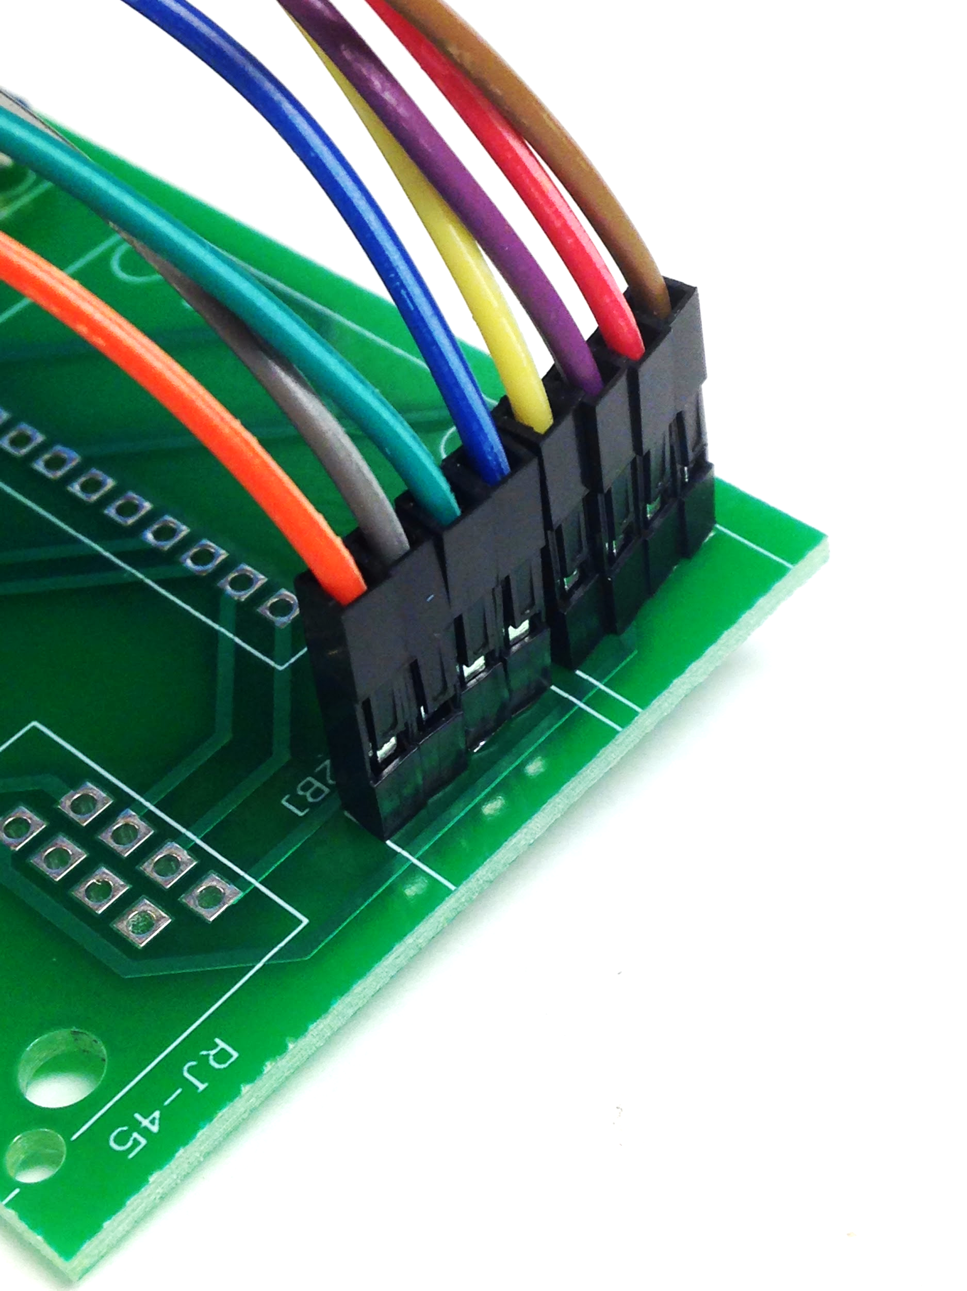

## Soldering the Sensors:

### Soldering the RJ-45 Jack:

Solder the component following the protocol of the previous RJ-45 jack

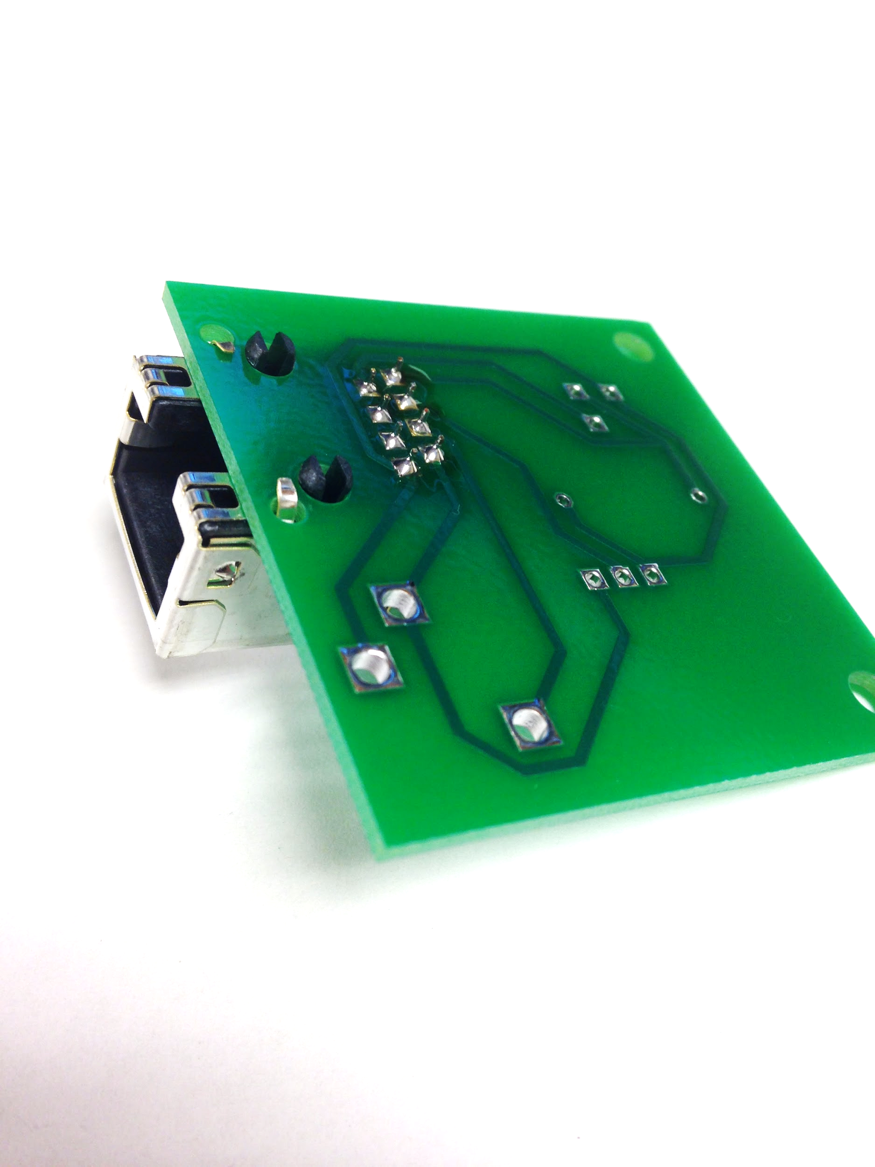

### Soldering the 3.5mm Jack:

Solder the component so that it is flush to the board and falls within the white printed perimeter.

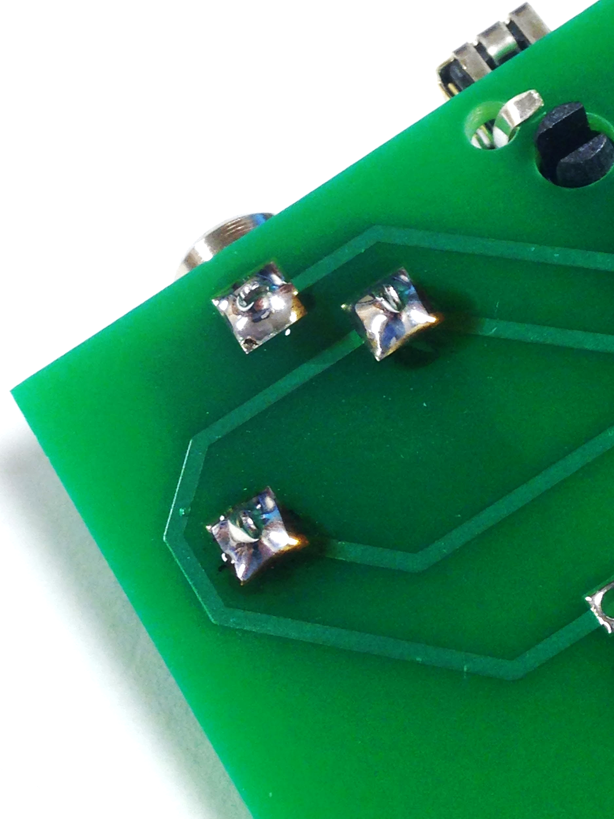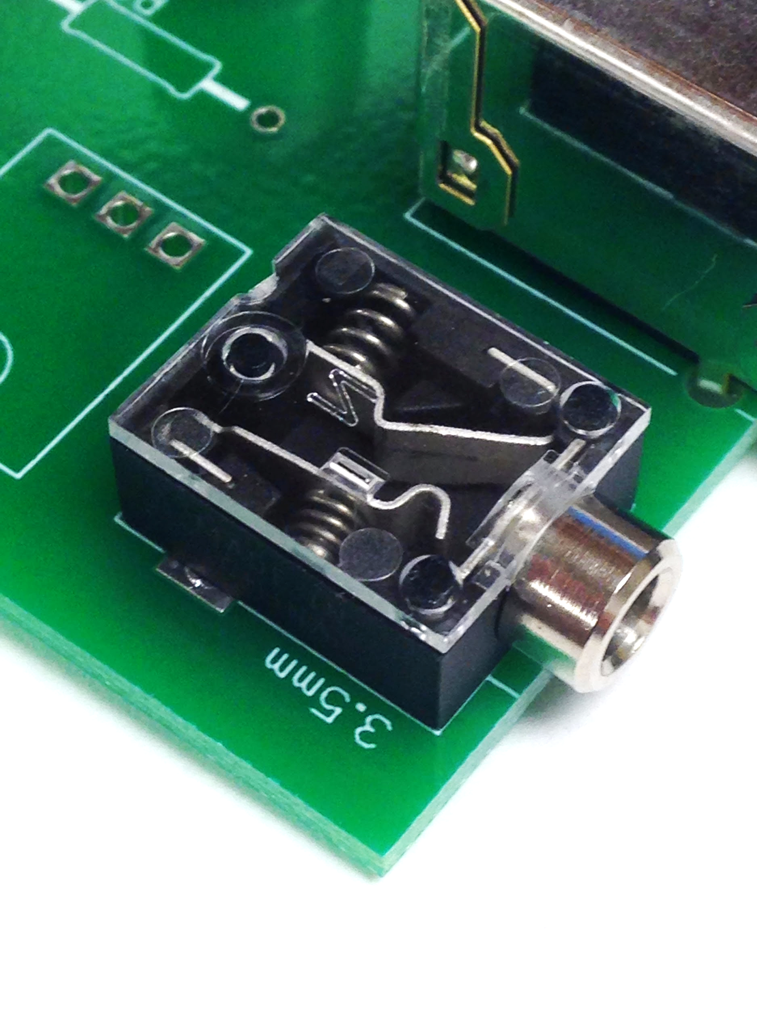

### Soldering the PIR:

Solder the component so that it is flush to the board and falls within the white printed perimeter.

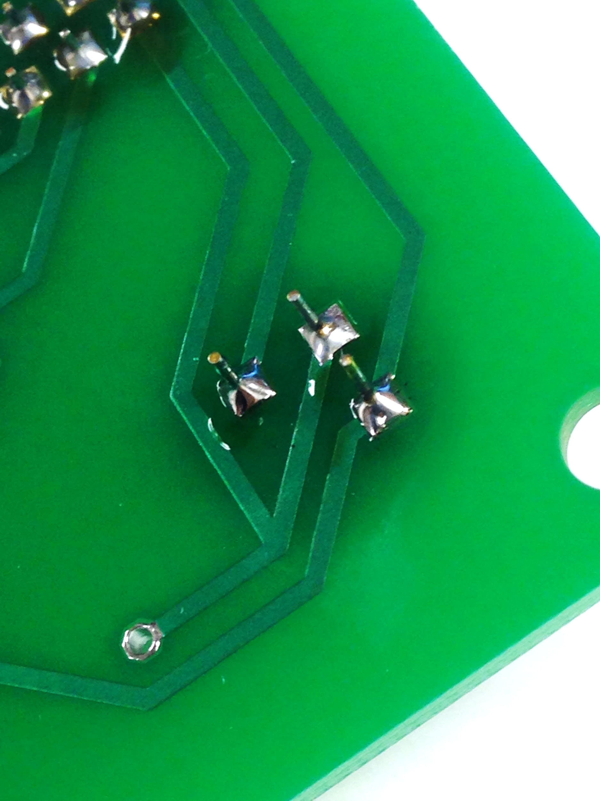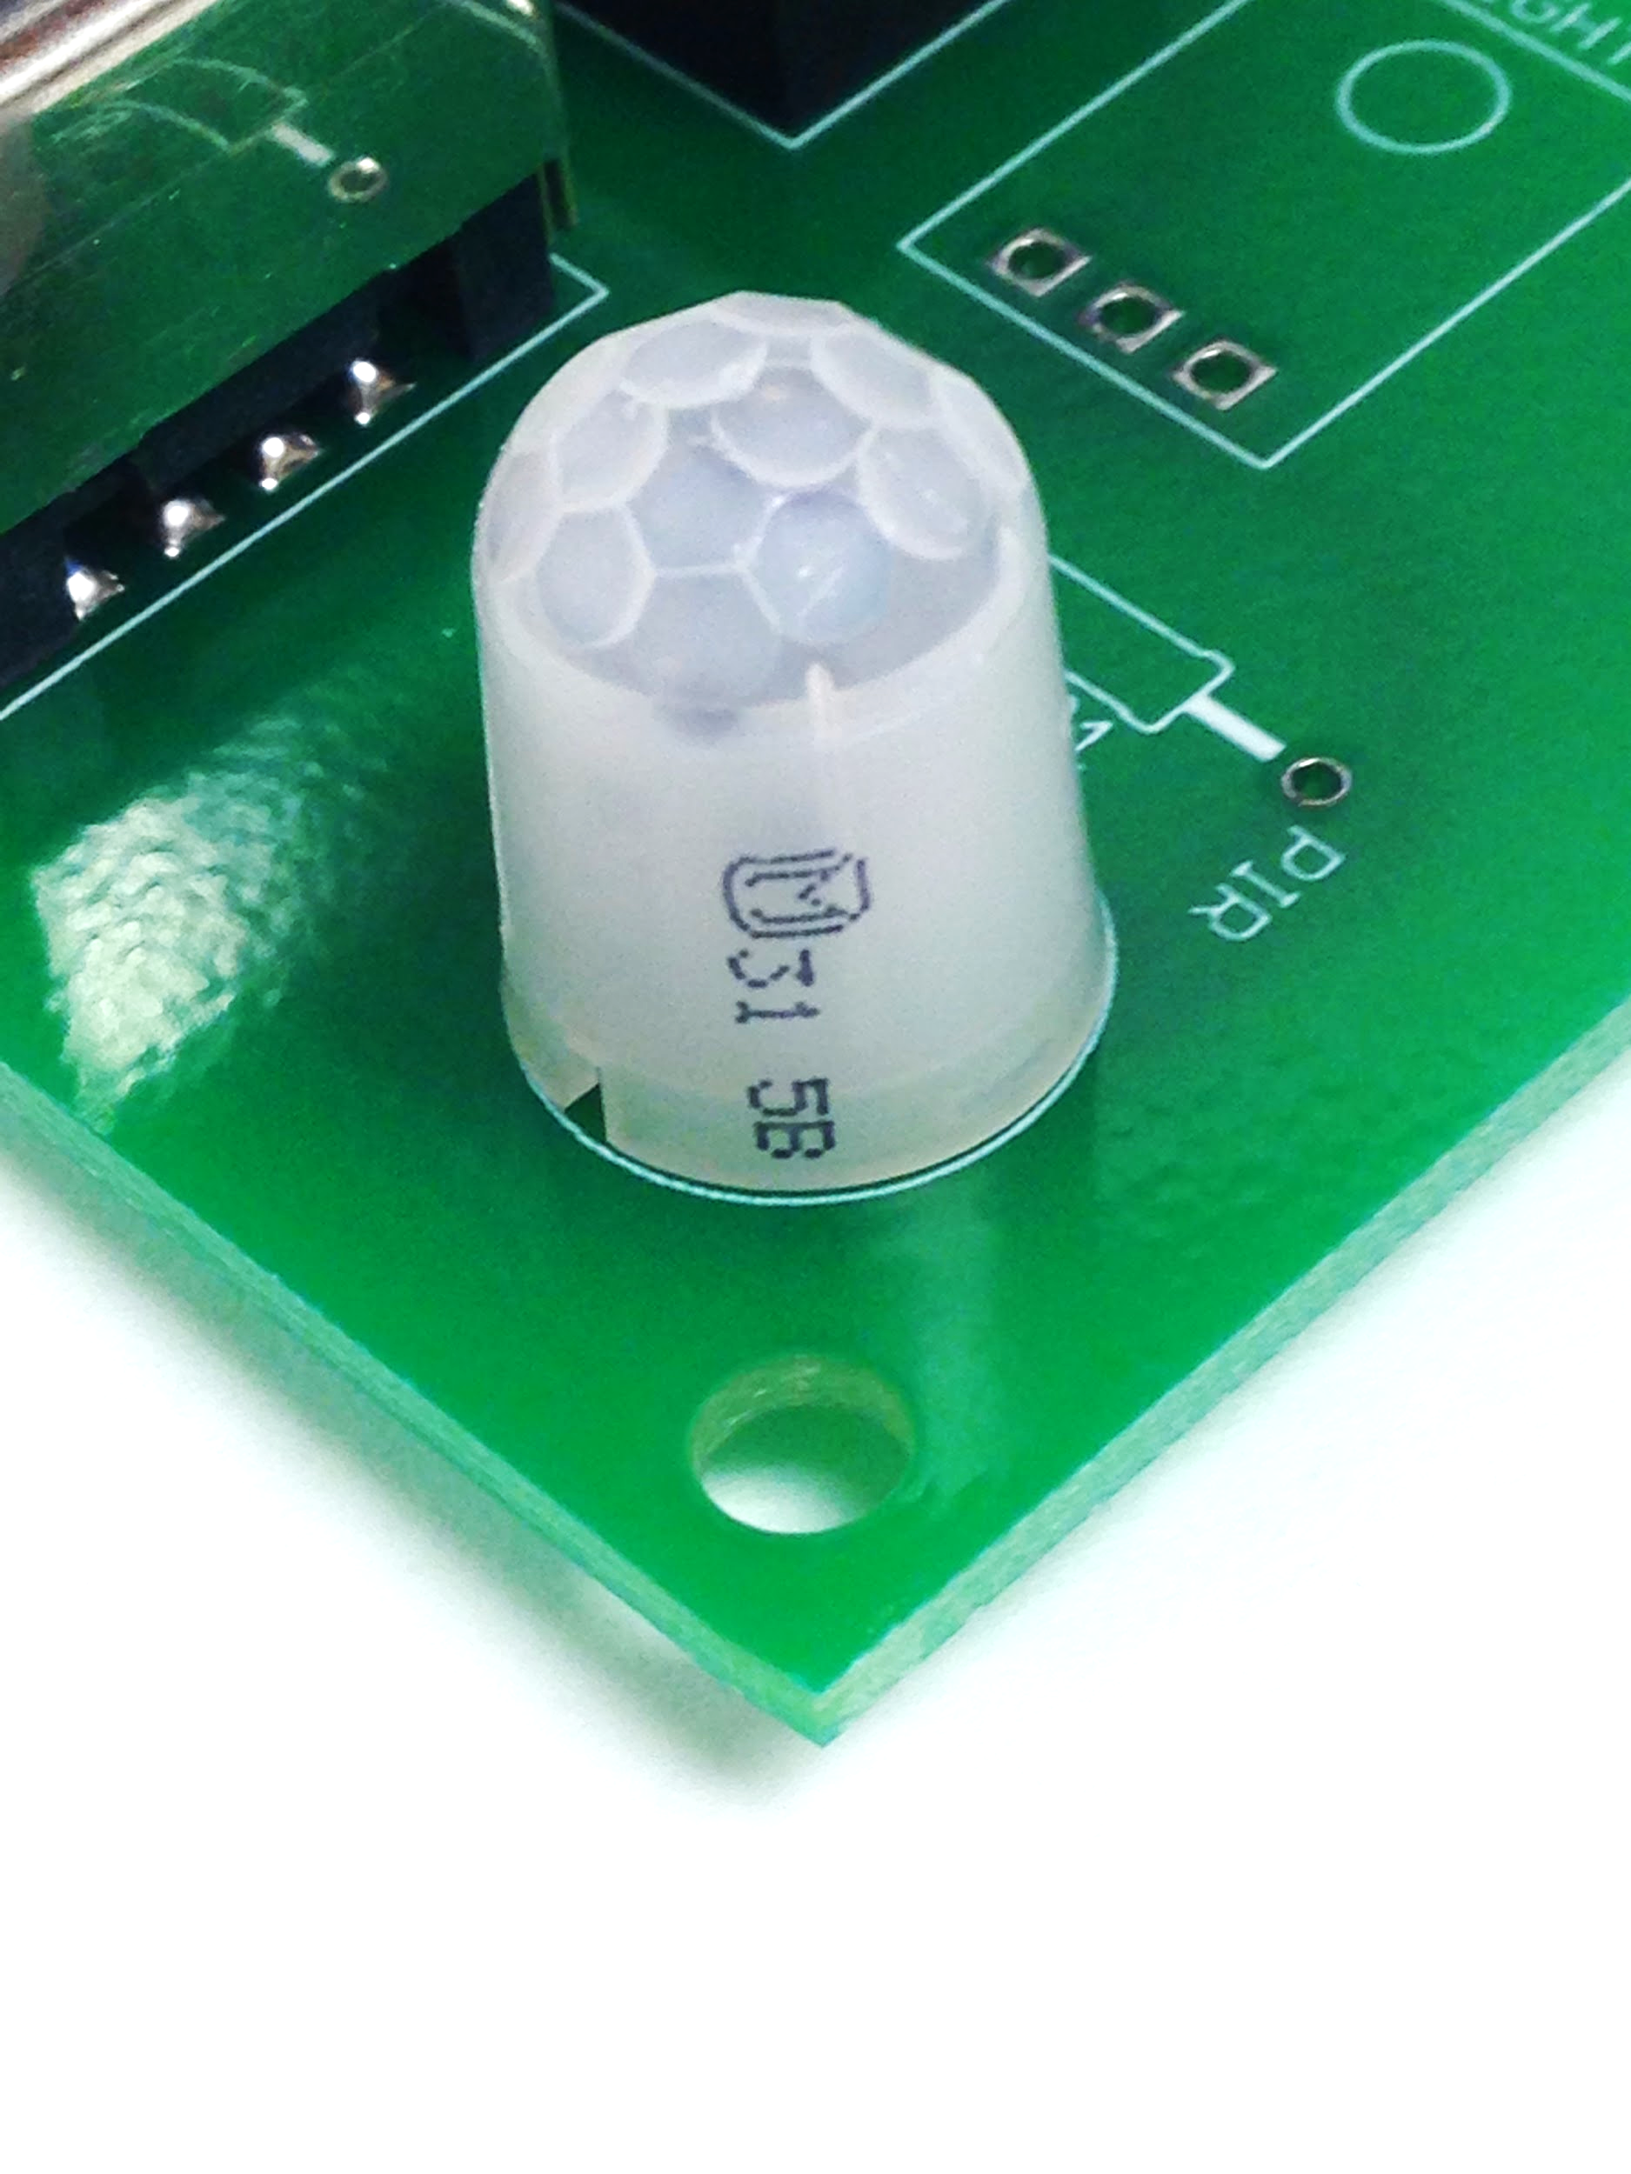

### Soldering the Resistor:

Bend the resistor leads so that it fits tightly within the printed white perimeter. Solder the leads at full length, and then cut the excess off once the resistor is soldered into place.

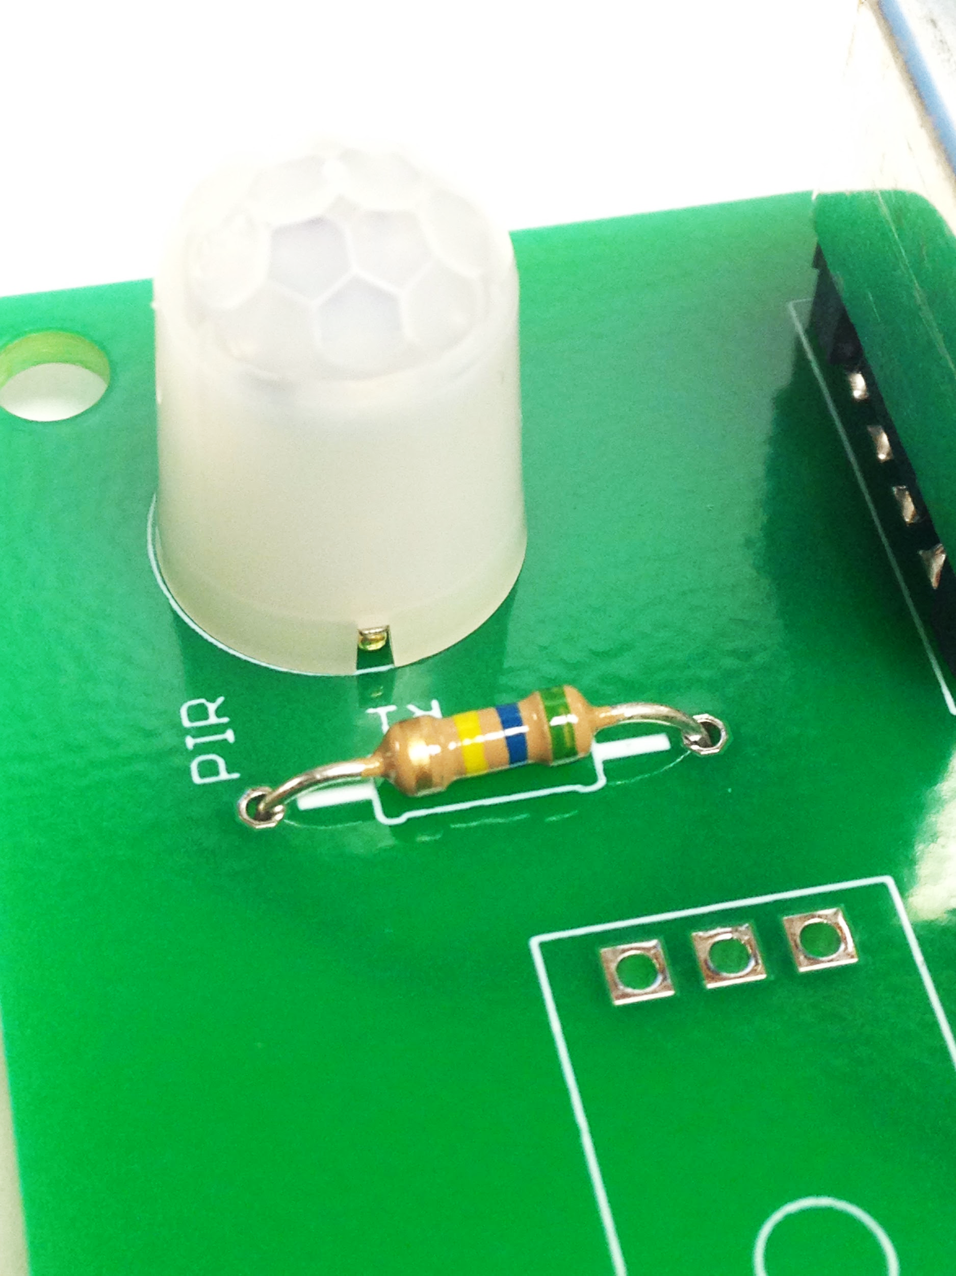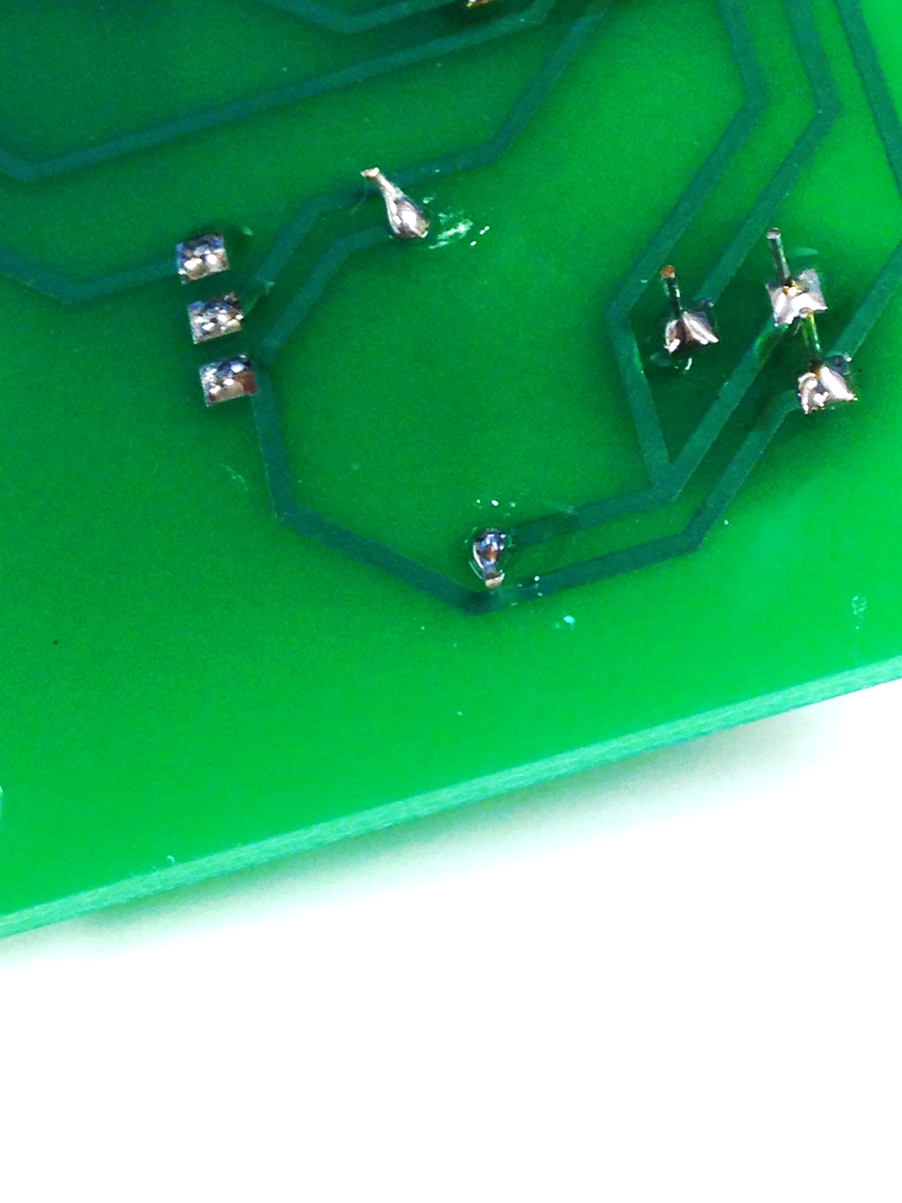

### Soldering the Light Sensor:

Start by soldering the three header pins onto the light sensor.

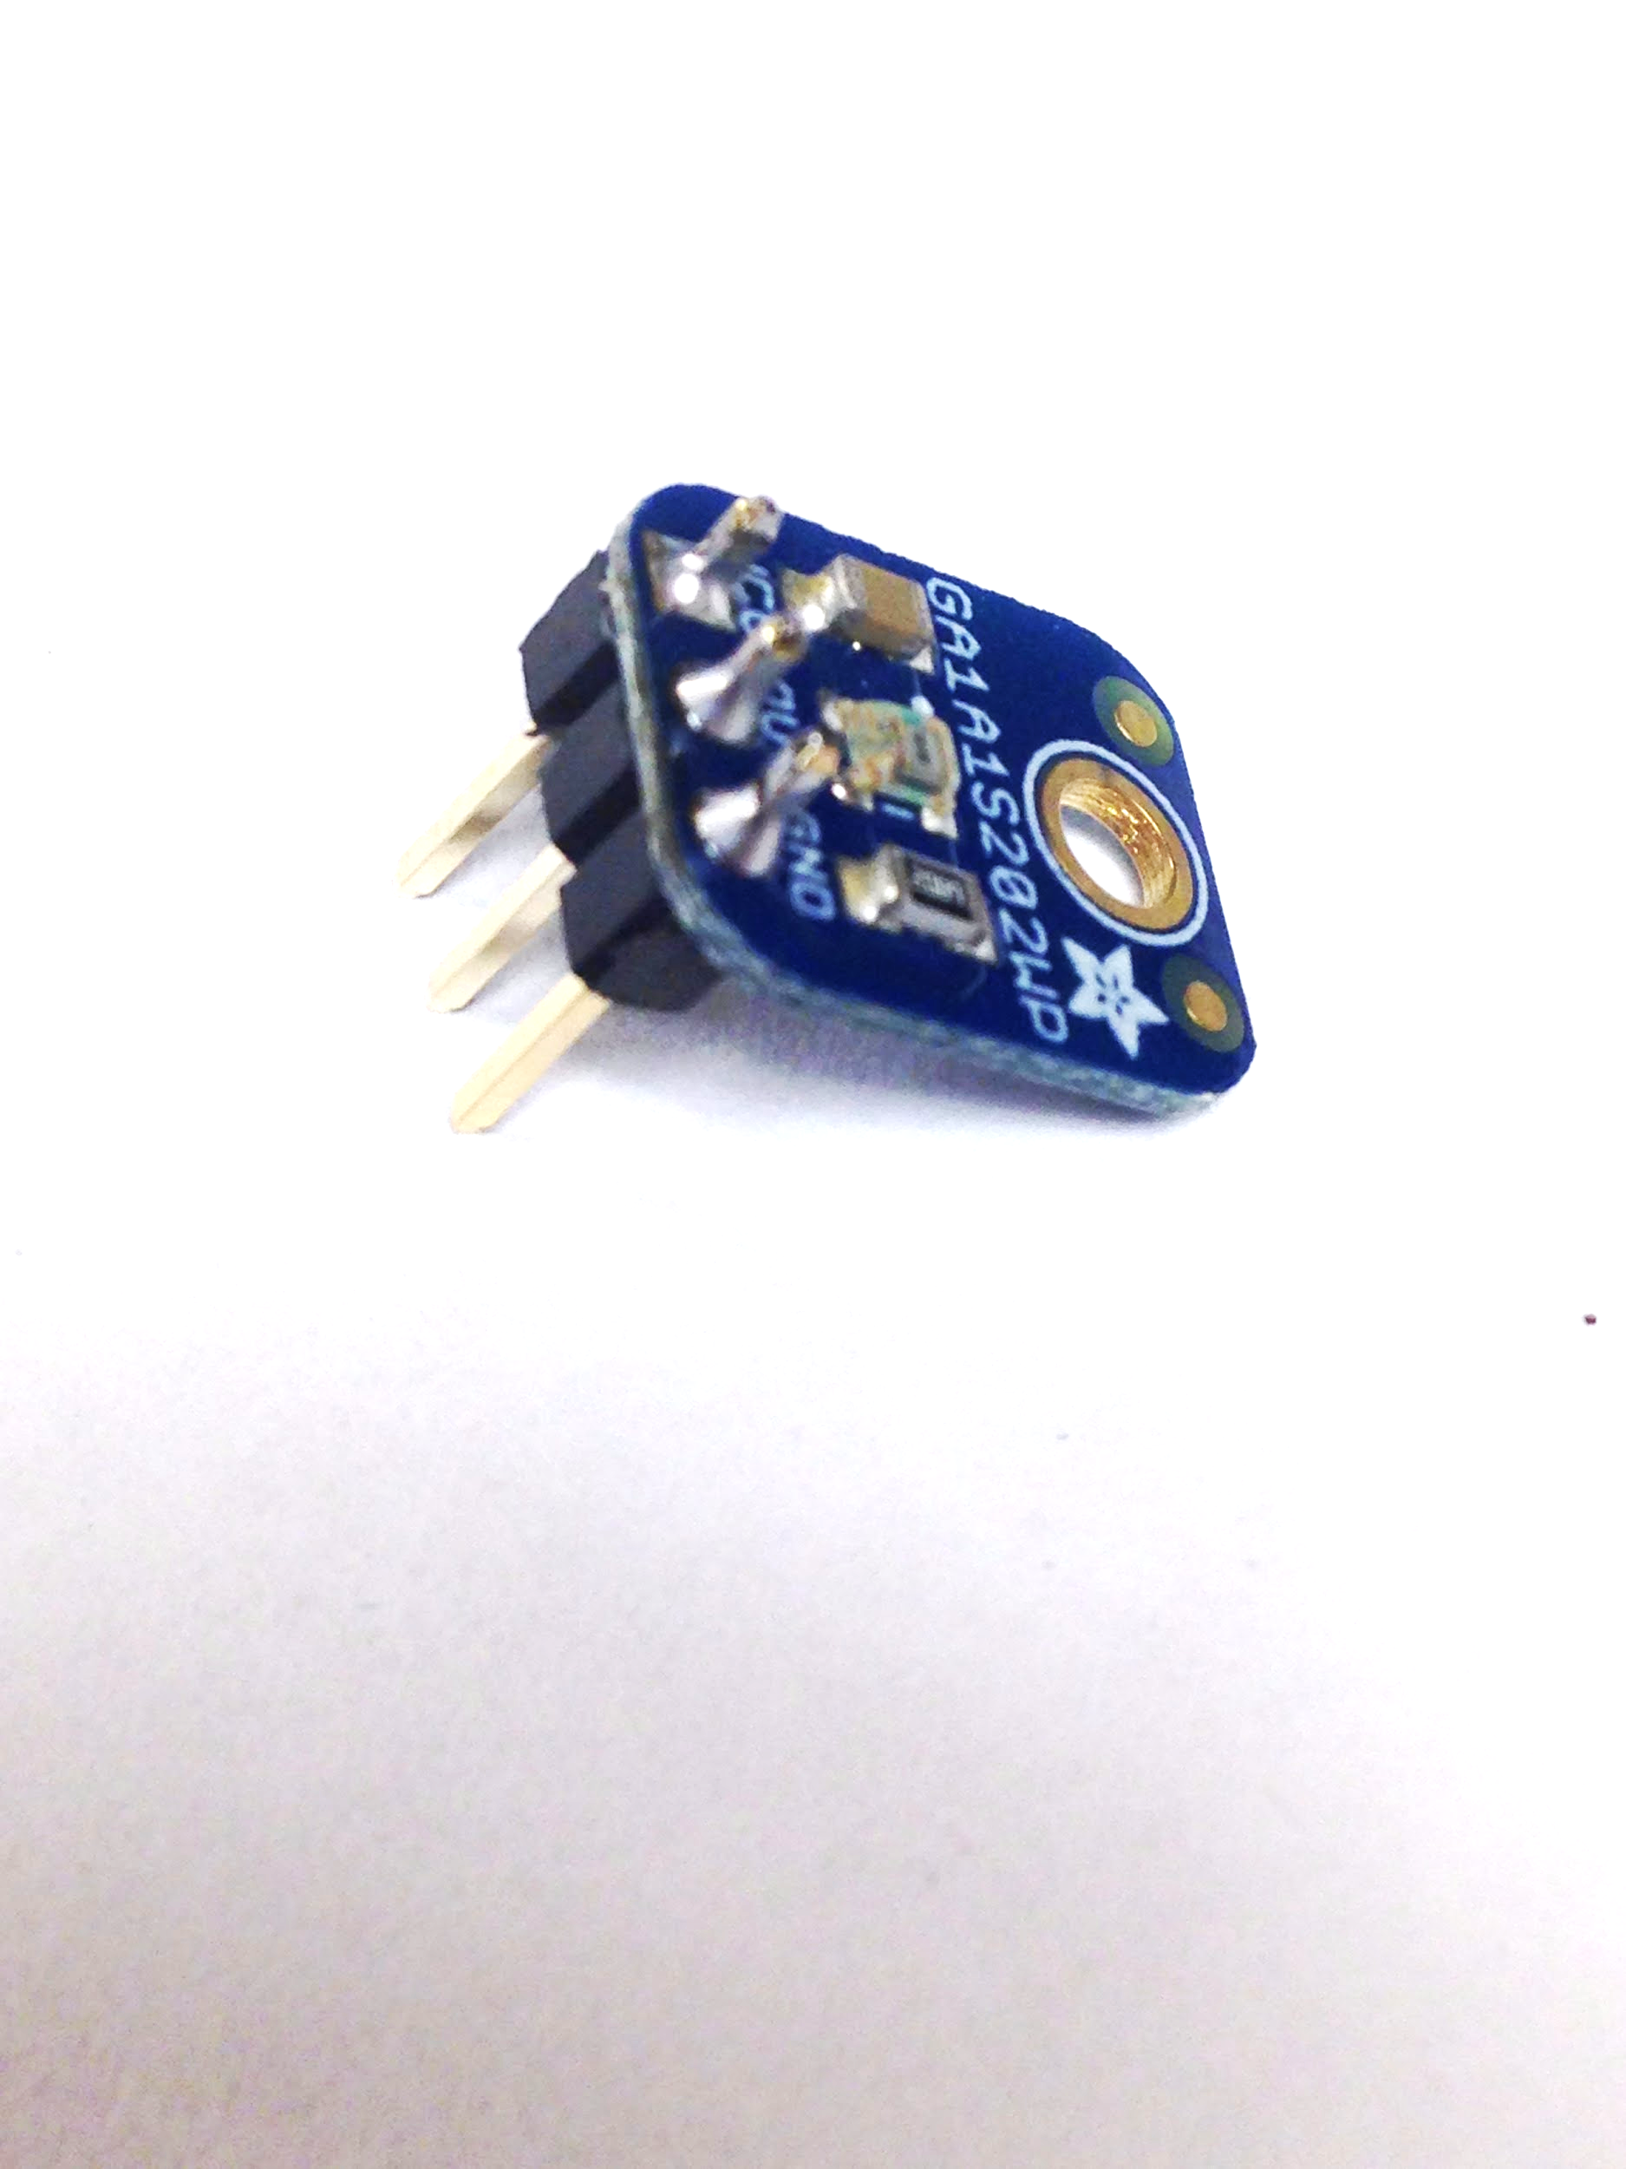

Finish by soldering the Light sensor elevated as high as possible.

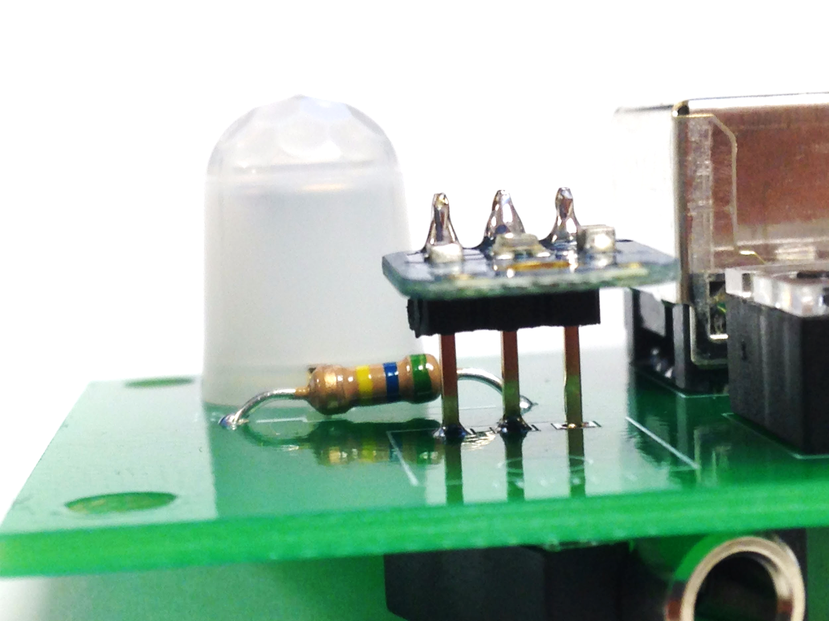

### Soldering the Temperature Sensor:

Start by cutting one connector off of a 3.5mm cable (Just connector and nothing more)

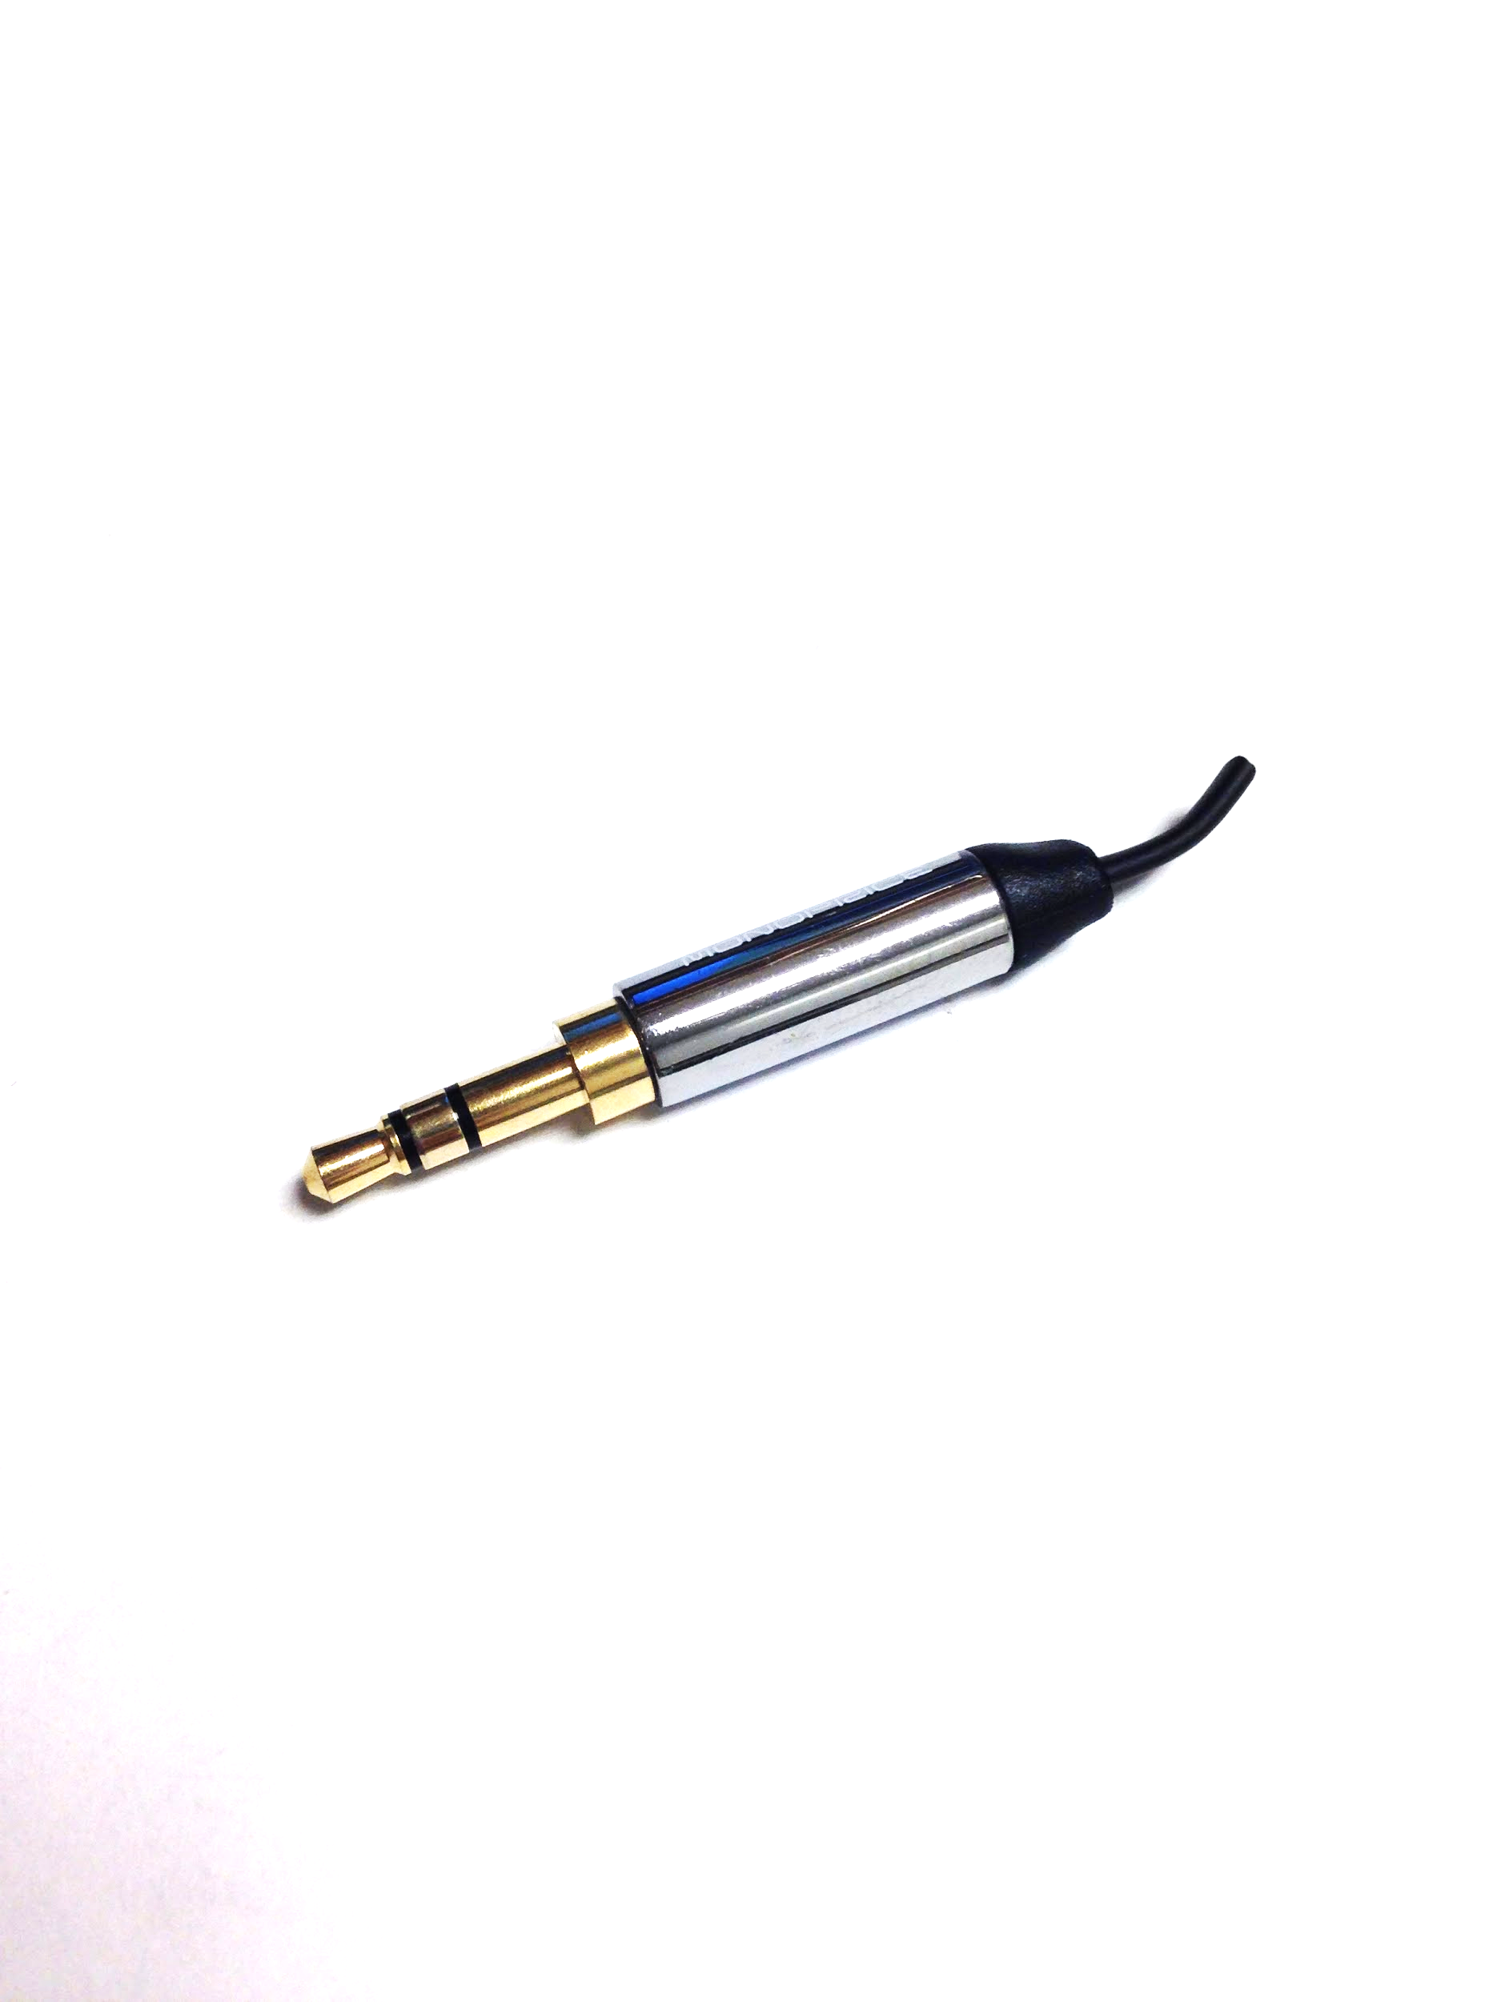

Next strip back the wire to expose the three cables inside (about three inches)

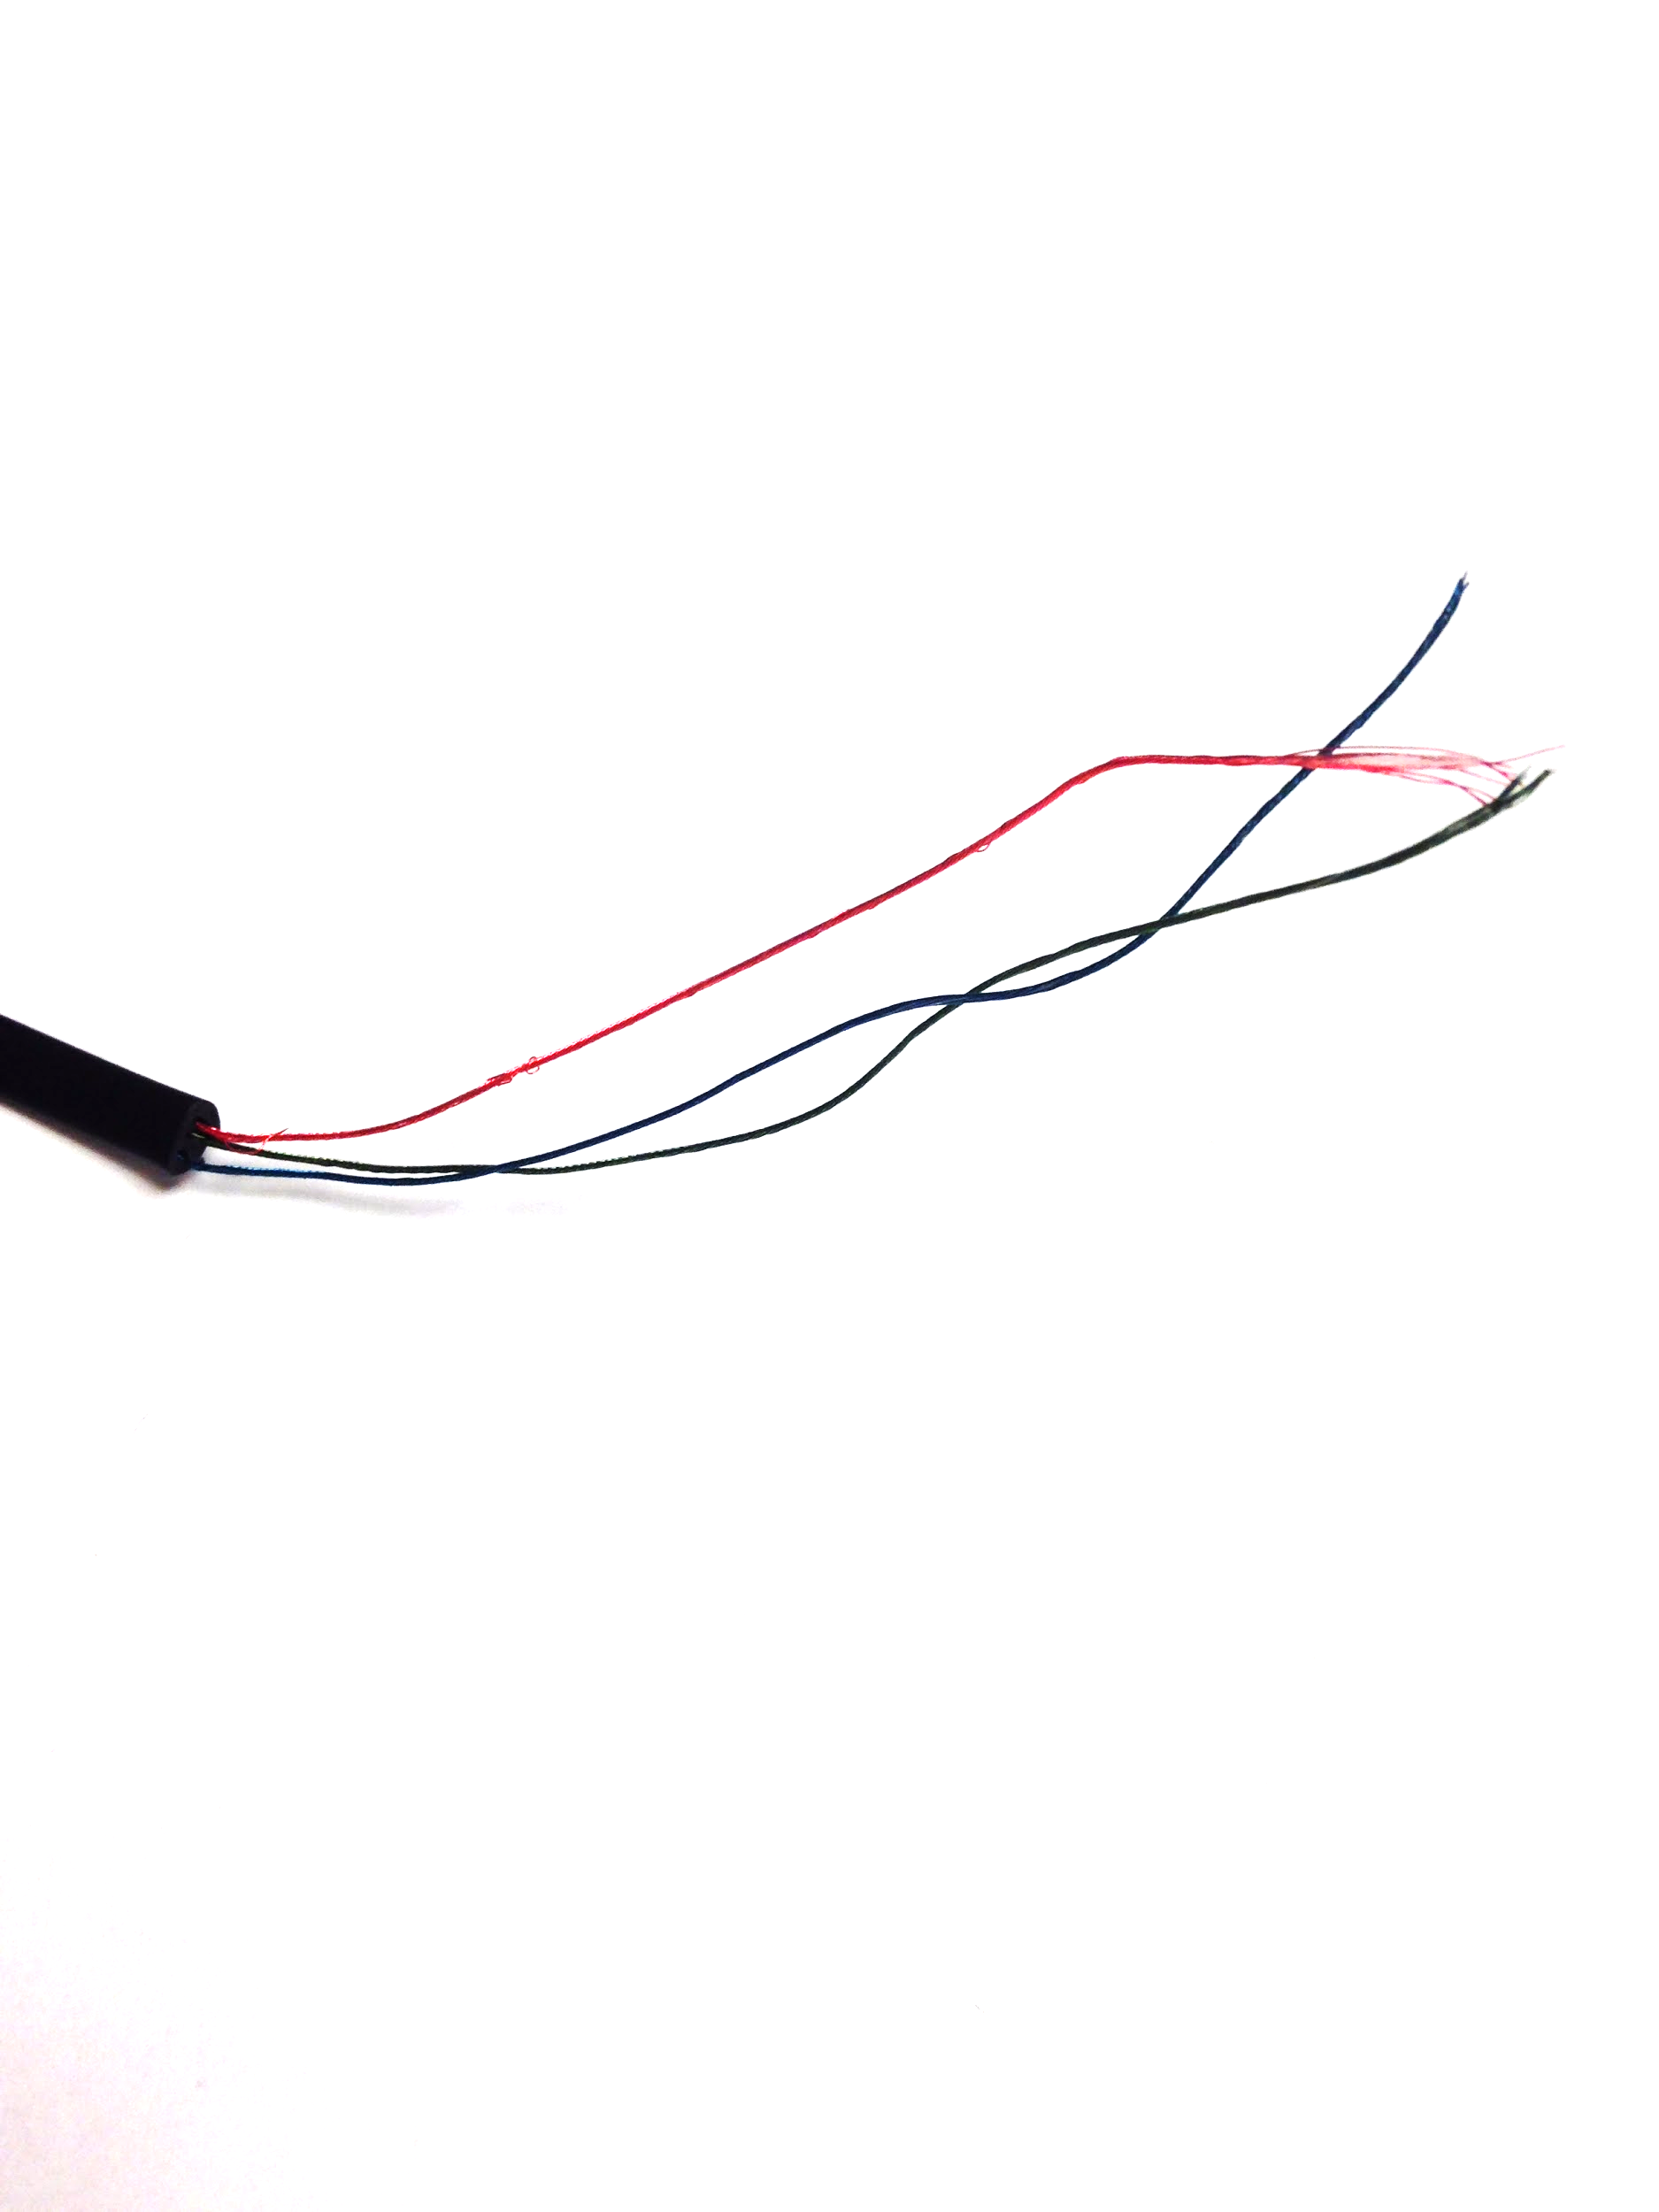

Put about 1.5-2.0" of 1/16" diameter shrink-tube onto the exposed wires.

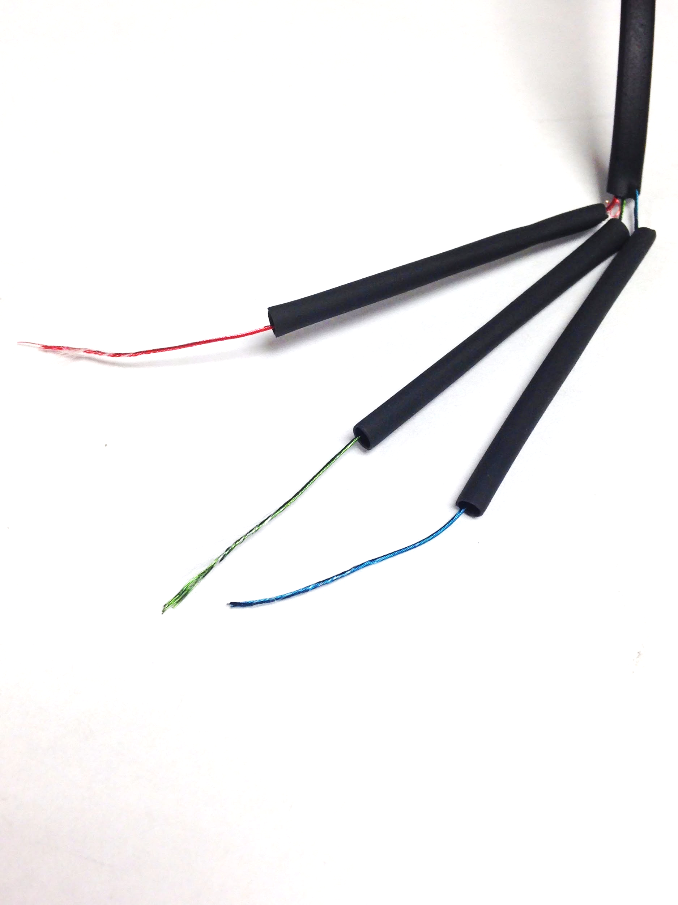

Put solder on the tips of the three leads of the temperature sensor and the tips of the three wires.

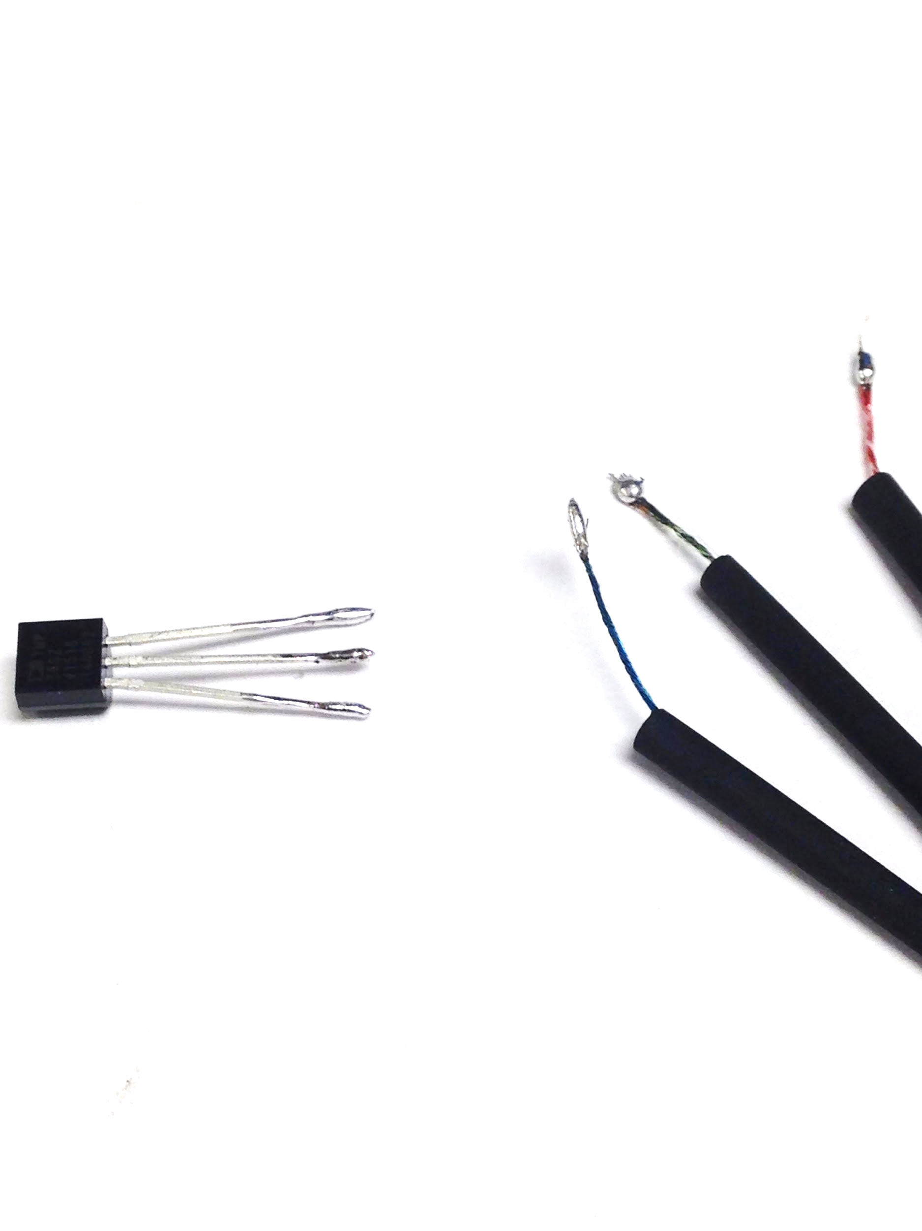

Connect the temperature sensor to the wires in the following configuration. The three pins on the temperature sensor need to be connected to specific wires on the 3.5mm cable. If the 3.5mm cables on the bill of materials are used the pins should correspond to the green, red, and blue wires. If a different cable is used refer to the tip, ring, and sleeve connections diagramed on the image.

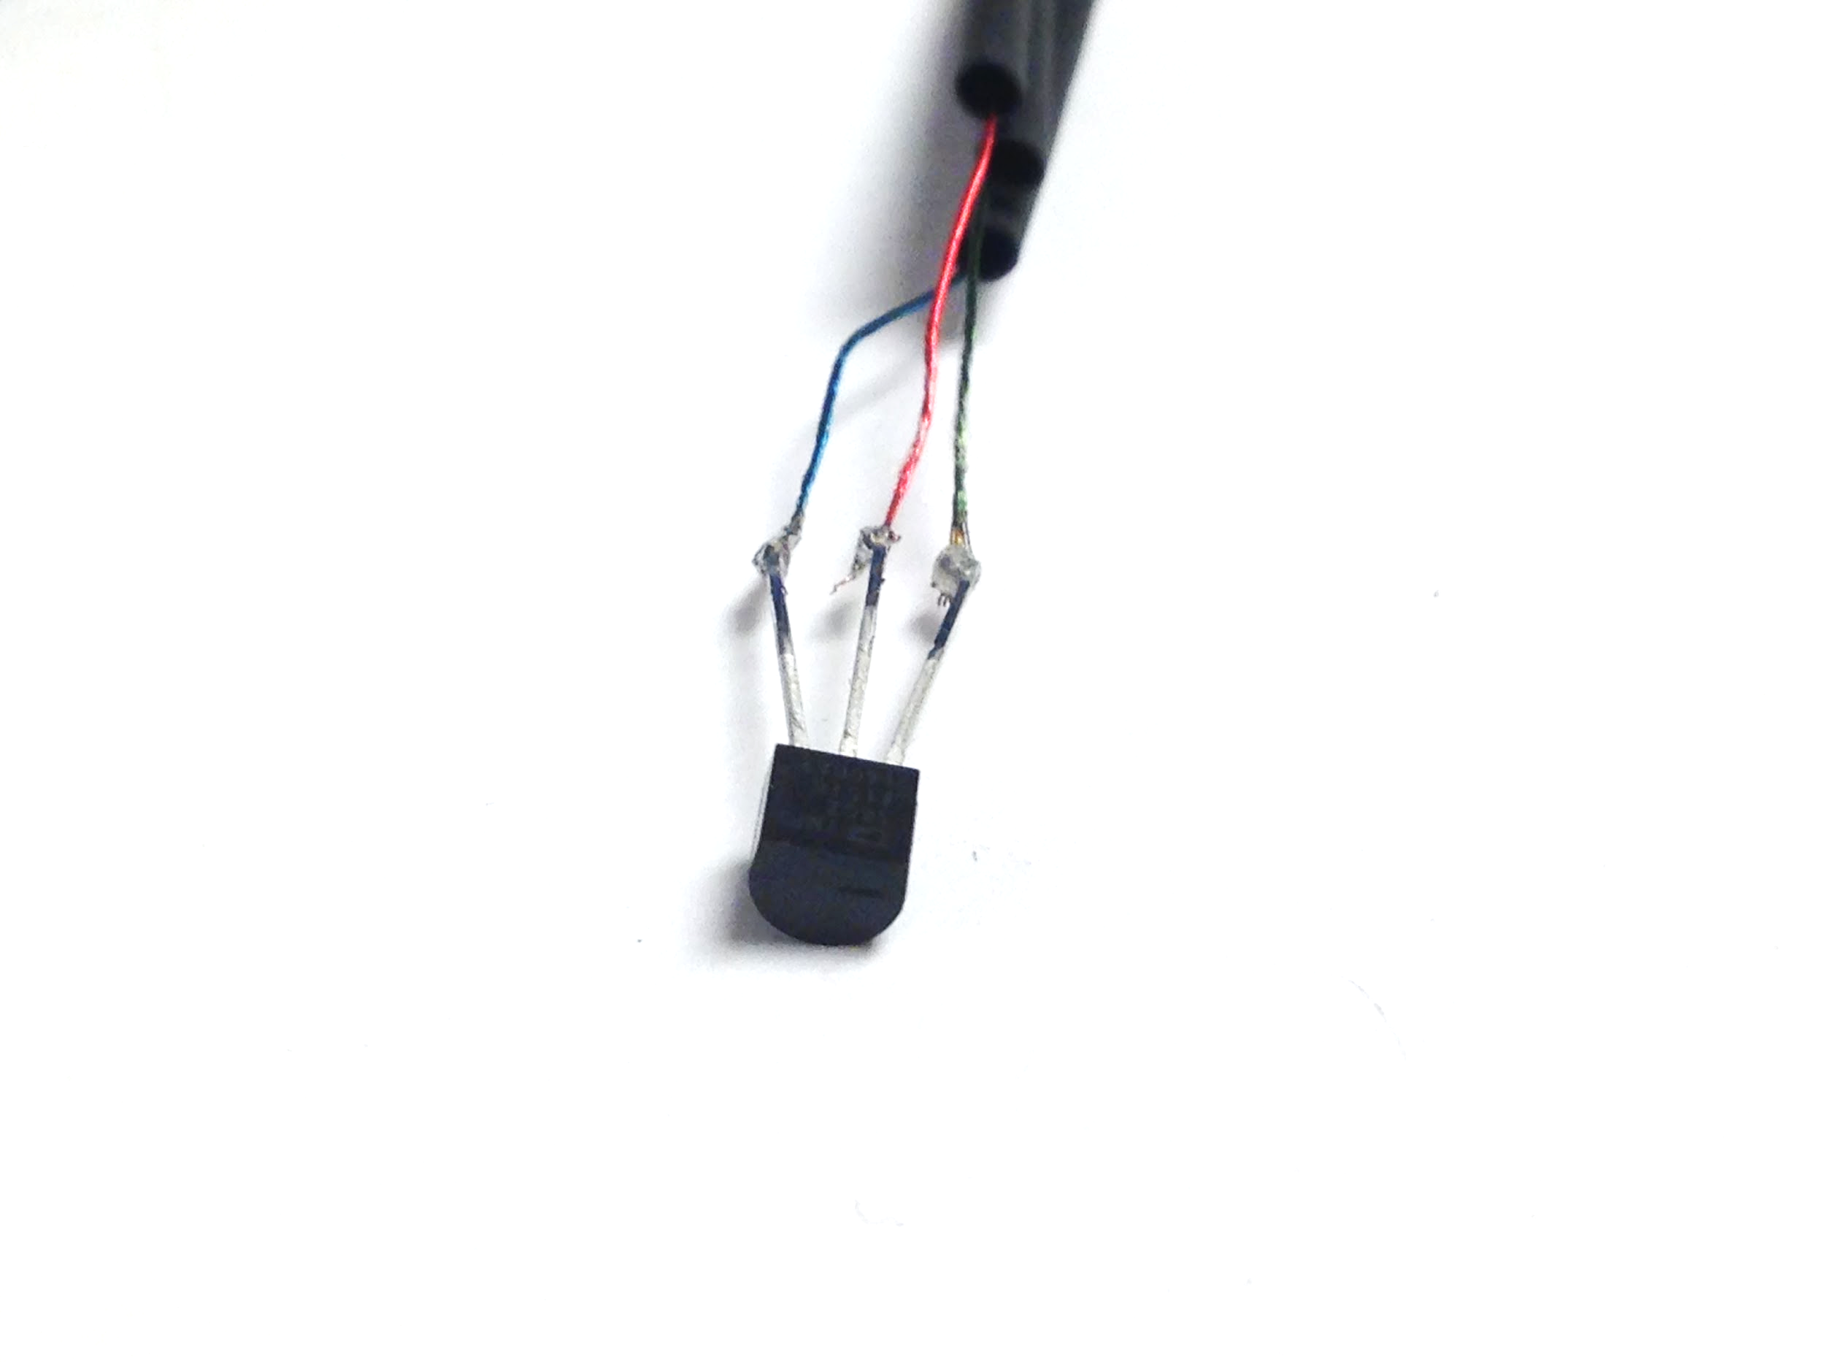

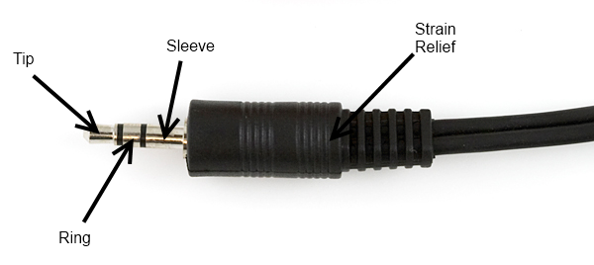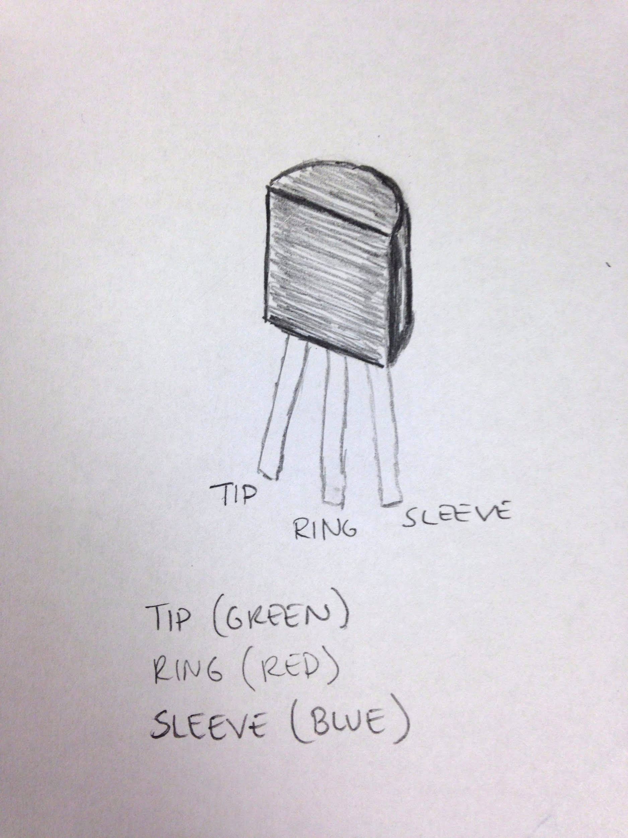

Slide the 1/16" diameter shrink tube up to the terminals of the temperature sensor and shrink the tubing.

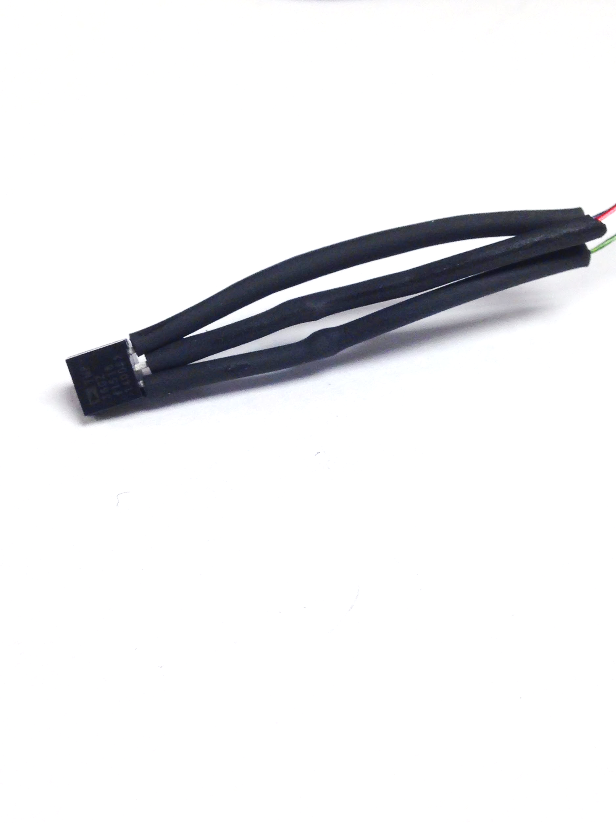

Finally, slide 2-3" of the 1/4" diameter shrink tube over the entire assembly so that it covers all of the wires and makes a neat package. Shrink the tubing.

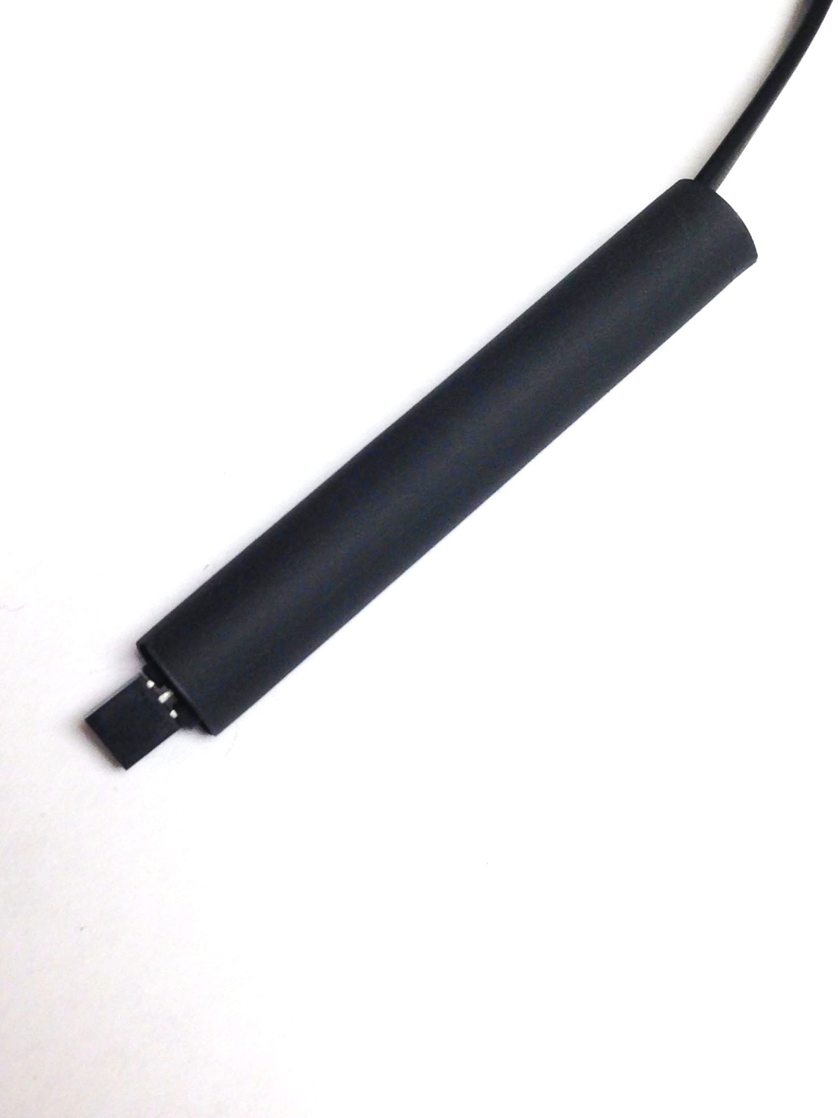

## Connecting The Raspberry Pi to the Hub:

Connect the Hub to the Raspberry Pi with the Dupont cables. The correct pin number that each dupont cable corresponds to is shown in the images below. A picture of the Raspberry Pi pinout is also provided for your convenience. The pin numbers follow the colon on the CAD drawing, and the pin numbers used are the ones printed in light gray underneath the Pin# heading.

## 

An Example of what the finished connections should look like:

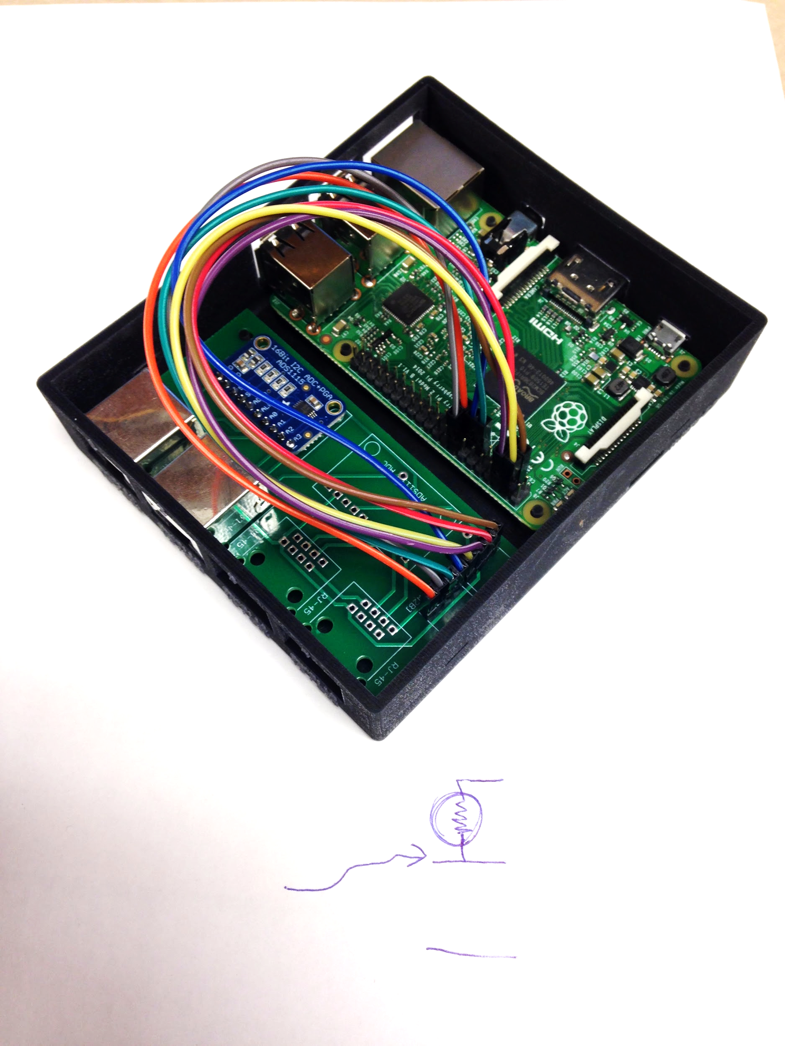

The circuit boards drop into the enclosure easily. (Make sure to put the SD card in before you put it in the box. You can take it in and out when the Raspberry Pi is in the box, but it is much easier to do so when it is out.)